Ellis Connolly, Head of Payments Policy
Reserve Bank of Australia
GPO Box 3947
Sydney NSW 2001

Dear Mr Connolly,
Thank you for the opportunity to provide our response to the Reserve Bank of Australia’s Review of Merchant Card Payment Costs and Surcharging consultation paper.
It is in every Australian’s interest to have a fair and competitive payments ecosystem.
Following our initial submission in December 2024, ANZ Worldline Payment Solutions is once again pleased to submit to the next round of consultation to contribute to greater transparency and competition in Australia’s payments ecosystem.
In the following pages, ANZ Worldline Payment Solutions has outlined a number of recommendations that address the key questions in this consultation paper.
Getting the regulatory regime right for both interchange fees and scheme fees is critical for a competitive and equitable payments system.
Currently, PSB’s proposals outlined in the consultation paper do not sufficiently address the impost of scheme fees on merchants and cardholders. Increased competition and material savings for merchant and cardholders will only be found through significant reforms to the operation of scheme fees.
Other proposals outlined in the consultation paper, including reforms to surcharging and increasing reporting requirements are supported by ANZ Worldline Payment Solutions and, with the right implementation approach could lead to a more competitive and efficient payment system for all Australians.
Should you have any questions about our submission, I can be contacted at john.collins@worldline.com.

Regards,
John Collins
Interim Chief Executive Officer
ANZ Worldline Payment Solutions

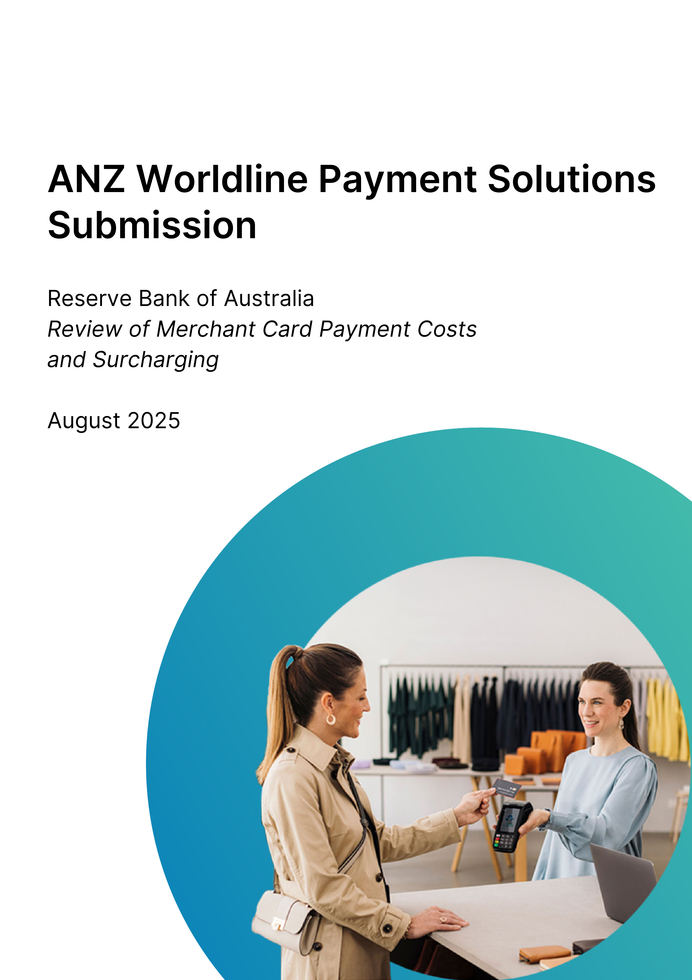

About ANZ Worldline Payment Solutions
ANZ Worldline Payment Solutions is a joint venture between global payments provider Worldline and ANZ Banking Group.
With its headquarters in Melbourne and locations in Sydney and Brisbane, ANZ Worldline Payment Solutions provides small, commercial and institutional businesses across Australia with technology for fast, reliable and secure point-of-sale and online payments.
It is part of Worldline [Euronext: WLN], a global leader in the payments industry and the technology partner of choice for merchants, banks and acquirers.
Worldline has ~18,000 employees and is active in more than 40 countries. It provides 1.4 million customers with services including in-store and online payment acceptance solutions along with commercial acquiring.

Overview and summary of recommendations
The Reserve Bank of Australia’s (PSB) Review of Merchant Card Payment Costs and Surcharging consultation paper presents a compelling case for reforms of Australia’s payment system to increase competition and transparency for the benefit of all participants.
So far, the PSB’ proposals have attracted significant media and stakeholder attention and – should they be implemented – would call for significant change.
But while a step in the right direction, it’s clear there is still significant opportunity for further reform to improve competition and efficiency in the payments system.
Getting the regulatory regime right for both interchange fees and scheme fees is critical for a competitive and equitable payments system. Currently, the PSB proposals outlined in the consultation paper do not sufficiently address the impost of scheme fees on merchants and cardholders. Material savings across the board will only be found through reforms to the operation of scheme fees.
Other proposals outlined in the consultation paper, including reforms to surcharging and increasing reporting requirements for payment service providers, are supported in-principle by ANZ Worldline Payment Solutions and, with the right implementation approach could lead to a more competitive and efficient payment system for all Australians.

Our top five recommendations for consideration in this review:
- While ANZ Worldline Payment Solutions recommends a cap on surcharging, not a ban, it will support the PSB’s proposed changes to surcharging.
- The PSB should provide more clarity regarding the role acquirers will play in enforcing a ban on surcharging.
- ANZ Worldline Payment Solutions supports lowering interchange fees as this will improve competition and efficiency in the payments system and ensure small to medium sized businesses (SMBs) are not disadvantaged by their lack of ‘buying power’ compared to big businesses.
- ANZ Worldline Payment Solutions proposes further regulation to address the impost of scheme fees on merchants.
- ANZ Worldline Payment Solutions proposes that acquirers processing $2 billion in card payments should be included in the proposal for quarterly publication of costs of acceptance.

Surcharging – summary of what’s proposed:
The PSB proposes to remove the PSB’s current prohibition on ‘no-surcharge’ rules for debit, prepaid and credit cards for designated card schemes.

ANZ Worldline Payment Solutions response
As a key player in the payments ecosystem, ANZ Worldline Payment Solutions believes the PSB’s current regulatory approach to surcharging – which allows merchants to surcharge cardholders for the reasonable cost of accepting card payments – has been somewhat successful in promoting the efficiency of the payments system by encouraging cardholders to use lower cost payment methods.
While banning surcharging may appear to present immediate cost relief for cardholders, the cost of payment processing remains for small businesses.
As expanded further throughout our submission (pp.9-11), if surcharging is banned but scheme fees remain unchanged, there may be no material saving for cardholders as businesses find other ways to pass on the cost.

Related discussion paper questions
Q1: Would removing surcharging on designated card networks best support the PSB’s objectives to promote the public interest through improving competition, efficiency and safety in the payments system?
In particular, the PSB welcomes feedback on whether there are additional public interest considerations that should be taken into account for each policy option.
- While our initial submission (December 2024) proposed a cap on surcharging, not a ban, ANZ Worldline Payment solutions will support the PSB’s proposed changes to surcharging. Overall, this better addresses payment processing cost issues facing businesses and promotes competition, efficiency, and transparency in the payments system.
- Ensuring safety in the payments system, as outlined in PSB’s proposal will require enforcement to ensure compliance.
- It’s clear, under the PSB’s proposed approach, that acquirers will be expected under scheme rules to enforce surcharging bans by passing on scheme fines for surcharging to merchants.
- Acquirers will need to retain some of the reduced interchange costs to cover costs associated with enforcing surcharging bans.
- Resourcing will also be required to ensure oversight of third parties– such as POS providers – who also enable surcharging on behalf of merchants.

Surcharging: ANZ Worldline Payment Solutions recommendations
- While ANZ Worldline Payment Solutions recommends a cap on surcharging, not a ban, it will support the PSB’s proposed changes to surcharging.
- The cost of enforcing surcharging bans will fall to acquirers. This cost will need to be recovered through retaining some of the decrease in interchange costs that result from these changes.

Interchange fees – summary of what’s proposed:
The PSB proposes the following actions on interchange:
- Reduce interchange on domestic debit (and prepaid) card transactions to a weighted-average benchmark of 6 cents per transaction with a cap of 6 cents or 0.12 per cent of transaction value on individual interchange fees.
- Reduce the cap on domestic credit card transactions to 0.3 per cent of transaction value and remove the weighted-average benchmark of 0.5 per cent.
- Introduce a cap on foreign-issued card transactions acquired in Australia of 0.2 per cent of transaction value for debit and 0.4 per cent for credit for card-present transactions, and 1.15 per cent for debit and 1.5 per cent for credit for card-not-present transactions.
- Amend the net compensation provisions to include international transactions and capture Australian issuers sponsored by overseas entities.

ANZ Worldline Payment Solutions response
Getting the regulatory regime right for interchange fees is critical for a competitive and equitable payments system.
ANZ Worldline Payment Solutions believes interchange fee regulation has contributed to a more efficient payment system. This is particularly evident when compared with other global markets – such as the US – where interchange regulation has become a serious cost impost for businesses.
ANZ Worldline Payment Solutions believes interchange fee schedules are only one part of the equation. Their regulation must be considered alongside reform considerations to also cap scheme fees.

Related discussion paper questions
Q2: Do the proposed changes to interchange regulation promote the public interest by improving competition and efficiency in the payments system?
- ANZ Worldline Payment Solutions believes the existing interchange fee arrangement is too complex and that regulation requiring card schemes to simplify interchange hierarchies would create a more competitive and efficient payments system.
- ANZ Worldline Payment Solutions believes lowering the interchange fee is in the public interest and will improve competition and efficiency in the payments system.
- In principle, ANZ Worldline Payment Solutions supports an appropriate level of capped interchange fees.
- Capped interchange fees will assist smaller businesses and make for a fairer playing field, given they lack the ‘buying power’ of larger enterprise businesses.
- Future assessment and industry consultation should be undertaken by the PBS to ensure the proposed caps are appropriate for both in-store and ecommerce transactions. If required, the PBS should revise its proposed capping regime to better reflect in-store vs ecommerce transaction costs.
- Capped interchange fees drives equity across big and small merchants, enabling a more competitive market and operating environment for smaller merchants.

- The PSB’s proposal to cap interchange fees addresses only part of the costs for processing payments.
- Historically, when interchange fees have been lowered, card networks have subsequently increased scheme fees resulting in no savings for the merchant.
- Regulation of interchange only works if scheme fee caps are introduced at the same time.
Q3: Are there further considerations for smaller issuers that the PSB should take into account to enhance competition and efficiency in the payments system?
- ANZ Worldline Payment Solutions has no recommendation regarding considerations for smaller issuers.
Q4: Do the proposed changes to the net compensation provisions effectively achieve the PSB’s objectives and promote the public interest? Will Australian issuers sponsored by overseas entities be able to comply with the changes?
- ANZ Worldline Payment Solutions has no recommendation regarding considerations for Australian issuers sponsored by overseas entities.

Interchange fees: ANZ Worldline Payment Solutions recommendations
- ANZ Worldline Payment Solutions believes lowering the interchange fee is in the public interest and will improve competition and efficiency in the payments system and ensure SMBs are not disadvantaged by their lack of ‘buying power’ compared to big businesses.
- Future assessment and industry consultation should be undertaken by the PBS to ensure the proposed caps are appropriate for both in-store and ecommerce transactions. If required, the PBS should revise its proposed capping regime to better reflect in-store vs ecommerce transaction costs.
- Regulation of interchange fees will only work if scheme fee caps are introduced at the same time.

Schemes and scheme fees – summary of what’s proposed:
The PSB proposes the following actions on wholesale fee transparency and complexity:
- Require card networks to publish quarterly aggregate interchange fee data, broken down by key transaction types.
- Require card networks to publish quarterly aggregate scheme fee data, broken down by key transaction types.
- The PSB to set an expectation that card networks work with industry to reduce the complexity and improve the transparency of their scheme fee schedules.

ANZ Worldline Payment Solutions response
ANZ Worldline Payment Solutions believes Scheme fees are an important component of the overall costs faced by merchants to accept card payments.
Scheme fees have risen over time putting upward pressure on card payment costs for merchants.
The current volume and complexity of scheme fees creates an opaque environment for merchants and cardholders alike. It needs to change.

Related discussion paper questions
Q5: Does the proposal for card networks to publish aggregate wholesale fee data achieve the PSB’s objectives of improving competition and efficiency among the card networks? Does the proposal adequately balance the information needs of the market with commercial concerns?
- ANZ Worldline Payment Solutions does not believe the PSB’s proposal adequately balances the information needs of the market with commercial concerns.
- ANZ Worldline Payment Solutions believes the proposal for card networks to publish aggregate wholesale fee data will not improve competition and efficiency unless it is aligned with the cost of acceptance.
- Scheme fees are complex and hard to understand, and pricing is opaque. They have increased in complexity and number since interchange fees were capped.
- The schemes also frequently change and restructure their interchange hierarchies.
- This complexity makes it difficult for businesses to understand wholesale fee structures.
- As a result, the PSB’s proposal for card networks to publish aggregate wholesale fee data does not achieve the PSB’s objectives of improving competition and efficiency.

Q6: Does the proposal for card networks to work with industry to reduce the complexity and improve the transparency of their scheme fee schedules enhance the competitiveness and efficiency of the card payments system?
- ANZ Worldline Payment Solutions does not believe the PSB’s proposal for card networks to ‘work with industry to reduce complexity and improve transparency of their scheme fee schedules’ will enhance competitiveness and efficiency of the card payment system.
- For many years, Australian acquirers have been persistent and vocal in their engagement with card networks towards simpler and more transparent scheme fees.
- Despite this, scheme fees have become progressively more complex and opaque.
- ANZ Worldline Payment Solutions believes the PSB should mandate card networks to simplify - by reducing the number of categories - scheme fees and provide merchant-friendly explanations of the purpose of each scheme fee.

Q7: Does the proposed expectation on scheme fees achieve the PSB’s objectives of competition and efficiency in the payments system?
- The PSB’s proposed expectations on scheme fees will not deliver on the objectives of further competition and efficiency in the payments system.
- ANZ Worldline Payment Solutions strongly supports a more fulsome regulatory approach that includes:
  - Capping scheme fees per transaction (similar to the proposed changes to interchange fees).
  - Restricting the number of scheme fees a card network can have at a point in time. This will allow the acquirer to transparently pass through the interchange and scheme fee to the merchants and communicate the nature of these fees in pricing conversations.
  - Simplifying scheme fee schedules – these are often complex with fees being set as part of deliberate pricing strategies.

Q8: Should the PSB consider further regulatory measures in relation to the level of scheme fees to promote competition and efficiency in the payments system?
- ANZ Worldline Payment Solution believes the PSB’s proposal does not do enough to reform scheme fees in a material way to provide competition and efficiency in the payment system.
- Scheme fees need to be regulated (capped) and transparency of scheme fees needs to be improved.
- Scheme fee schedules are often complex and opaque, with fees being set as part of a deliberate pricing strategy by scheme providers:
  - ANZ Worldline Payment Solution proposes the establishment of standardised categories and dimensions to which all the Schemes need to adhere This will allow a consistent, industry-agreed methodology for introducing new categories, across all payment brands.
  - Schemes need to be restricted on the number of fees that can be introduced. This will allow the acquirer to transparently pass through the interchange and scheme fee to the merchants or communicate the nature of these fees in pricing conversations.

Scheme fees: ANZ Worldline Payment Solutions recommendations
- Scheme fees need to be regulated (capped) and transparency of scheme fees needs to be improved.
- In addition to publishing the total value of scheme fees collected, scheme fees should also publish volume and value of transactions processed through each network.

Transparency of merchant service fees – summary of what’s proposed:
- Require acquirers that process more than $10 billion in card payments annually to publish their merchants’ average costs of acceptance, broken down by merchant size and card type on a quarterly basis on their website (see Appendix D: Draft Standards).
- Amend requirements for acquirers’ cost of acceptance reporting on merchant statements to include (in addition to a breakdown of fees by card network) a breakdown of domestic and international transactions (see Appendix D: Draft Standards).

ANZ Worldline Payment Solutions response
ANZ Worldline Payment Solutions supports greater community awareness around payment service fees to ensure businesses – big and small – are better equipped to make decisions about payment processing fees.
In principle, ANZ Worldline Payment Solutions agrees that there is a significant need for community education and greater transparency around the cost of providing merchant services.

Related discussion paper questions
Q9: Does the proposed requirement for acquirers to publish their merchants’ cost of acceptance enhance competition and efficiency by helping merchants search for a better plan? In particular, the PSB welcomes feedback on:
- whether the size threshold for acquirers is appropriate
- whether the category breakdowns (merchant size and card type) are likely to be useful to merchants without compromising commercial sensitivity
- whether the quarterly frequency of publication is appropriate
- what an appropriate implementation timeline would be.

- ANZ Worldline Payment Solutions believes the size threshold proposed by the PSB does not represent an appropriate portion of the market that is responsible for processing card transactions.
- To ensure the proposal achieves its intended goal, ANZ Worldline Payment Solutions recommends acquirers processing $2 billion in card payments should be included in the proposal for quarterly publication of costs of acceptance, broken down by merchant size and card type.
- ANZ Worldline Payment Solutions believes the quarterly timing of additional reporting and publication requirements is appropriate and would seek to ensure that it aligns with other existing RBA reporting requirements.
- While ANZ Worldline Payment Solutions does not have an alternative view regarding an implementation timeline it encourages the PSB to have ongoing engagements with industry around the proposed implementation schedule.

Q10: Does the proposal to amend the cost of acceptance reporting on merchant statements to include a breakdown for domestic and international cards promote competition by helping merchants receive more information about the fees they pay? Is there a public interest case to exempt taxi fares from this requirement?
- ANZ Worldline Payment Solutions believes requiring acquirers to publish statements to include a breakdown for domestic and international cards will help small businesses to better understand their cost of payments.
- ANZ Worldline Payment Solutions has no recommendation regarding the taxi industry.

Transparency of merchant fees: ANZ Worldline Payment Solutions recommendations
- To ensure the proposal achieves its intended goal, it recommends acquirers processing $2 billion in card payments should be included in the proposal for quarterly publication of costs of acceptance, broken down by merchant size and card type.
- ANZ Worldline Payments Solutions would encourage the PSB to have ongoing engagements with industry around any implementation schedule.

LCR implementation – summary of what’s proposed:
The PSB proposes maintaining the status quo regarding the RBA’s expectations of LCR implementation in retail payments.

ANZ Worldline Payment Solutions response
ANZ Worldline Payment Solutions provides businesses with a variety of payment solutions that support their business needs. The ability to route to the lowest-cost payment network for a particular transaction is important for many businesses.
ANZ Worldline Payment Solutions offers Multi-Network Card Routing (MNCR) as standard to all new SMB customers on our ANZ Worldline Payments Solution payment platform.
We have significantly improved the number of merchants we enable with MNCR who have been recently migrated to our new payment platform.

Related discussion paper questions
Q11: Are there any changes that should be made to the PSB’s existing industry expectation on LCR implementation to improve competition and efficiency in the debit card market?
- ANZ Worldline Payment Solutions supports default Merchant Choice Routing (MCR) for small businesses. To ensure the intended benefits (for businesses and cardholders) of MCR are realised, ANZ Worldline Payment Solutions calls for certainty from the PSB that default MCR will always mean routing to the least cost payment network.
- MCR should be offered by default for all small businesses on the proviso it does not translate to a default route to eftpos.
- Regulation should support the ability for all schemes to compete for volume on a level playing field – which is not the case today. This will further stimulate competition.

Least Cost Routing: ANZ Worldline Payment Solutions recommendations
- MCR should be offered by default for all small businesses on the proviso it does not translate to a default route to eftpos.

Summary:
Related discussion paper questions
Q12: Does the PSB’s preferred package meet its objectives of competition, efficiency and safety in the payments system? Are there any variations to the package that the PSB should consider that would yield higher net public benefits? Is there any additional evidence that the RBA should consider before finalising its decision?
- ANZ Worldline Payment Solutions believes the PSB’s proposed reforms to encourage card providers and industry to work together will not deliver on its objectives of further competition and efficiency in the payments system.
- ANZ Worldline Payment Solutions believes that, should there be insufficient outcomes from this approach, the proposal for card networks to work with industry should be reviewed, and a more fulsome regulatory approach considered that includes:
  - Capping scheme fees
  - Restricting the number of scheme fees for card networks. This will allow the acquirer to transparently pass through the interchange and scheme fees to merchants and communicate the nature of these fees in pricing conversations.
  - Simplifying scheme fee schedules – these are often complex with fees being set as part of deliberate pricing strategies.
- ANZ Worldline Payment Solutions believes this approach would contribute to a more competitive and efficient payment system.

Q13: What is your feedback on the proposed implementation timeline for these reforms?
- ANZ Worldline Payment Solutions has no recommendation regarding the proposed implementation timeline for these reforms.

Q14: Do the draft standards in Appendix D achieve the intended policy objectives? Are there factors that have not been properly addressed or considered in the drafting of the proposed standards?
- ANZ Worldline Payment Solutions has no recommendation regarding the draft standards in Appendix D.

Other considerations
Are there any other considerations not currently tabled by the PSB?
- We need to fairly balance the needs, costs and benefits of a two-sided (cardholder and merchants) payments ecosystem, rather than having one side - merchants- enduring higher fees to fund cardholder benefits.
- Reforms that sustain a viable and innovation-friendly payments industry while making it fair and equitable for all stakeholders.
- If Australian cardholders are unable to benefit from the same advancements as international cardholders when buying products and services from merchants outside of Australia, there may be unintended consequences.

Further inquiries:

John Collins
Interim Chief Executive Officer
ANZ Worldline Payment Solutions
john.collins@worldline.com

ANZ Worldline Payment Solutions means Worldline Australia Pty Ltd ACN 645 073 034 (“Worldline”), a provider of merchant solutions. Worldline is not an authorised deposit taking institution (ADI) and entry into any agreement with Worldline is neither a deposit nor liability of Australia and New Zealand Banking Group Limited ACN 005 357 522 (“ANZ”) or any of its related bodies corporate (together “ANZ Group”). Neither ANZ nor any other member of the ANZ Group stands behind or guarantees Worldline.

https://www.rba.gov.au/payments-and-infrastructure/review-of-retail-payments-regulation/backgrounders/backgrounder-on-interchange-and-scheme-fees.html

