

INTRODUCTION
The Commonwealth Bank of Australia (CBA) welcomes the opportunity to respond to the Reserve Bank of Australia (RBA)’s Consultation Paper: Review into Merchant Card Payment Costs and Surcharging. These are important issues to deliver safe, sustainable, reliable and efficient payment services.
A well-functioning, sovereign payments system underpins a well-functioning society and the financial wellbeing of its people. It is deeply entwined with a nation’s economy – individuals and businesses benefit from safe and efficient payments infrastructure.
Australia has an enviable record of payments innovation and regulation. We have among the highest adoption of tap-to-pay and digital wallet technology, the lowest interchange rates, and strongest consumer protections. We are one of a handful of countries with both a domestic cards scheme and real time account payment system. Our payments system is among the safest, most efficient and innovative in the world.
The systemic importance of the payments system rightly attracts a high level of regulation, to ensure confidence and trust in the system. It aims to promote safe, sustainable, reliable and efficient payment services, for the benefit of the community. Striking this balance will always be important, and shifts in emphasis are required to respond to changes in the external context.
The recent amendments of the Payment System Regulation Act (PSRA) are timely. It is critical that payments are regulated comprehensively. There are several important existing and emerging issues that impact the efficiency, sovereignty, and sustainability of our payments system that are better addressed with the RBA’s expanded powers than under the historical regulatory approach.
We agree with the Reserve Bank that surcharging for both debit and credit payments should be banned. As the Consultation Paper notes, the price signal to consumers has become less effective for a number of reasons, it is challenging for the ACCC to enforce compliance, and some PSPs have gone beyond the spirit of the regulations.
We also support the Reserve Bank’s intent to lower costs for small businesses. Small businesses play a very important role in economic dynamism and job creation, and are responsive to changes in incentives. We believe that there may be an alternative model to the proposals described in the Consultation Paper which would better support small businesses.
We have built an alternative approach around three principles: i) continuing to deliver interchange cost outcomes that are among the lowest markets globally, namely the EU and UK; ii) delivering relief to small businesses; and iii) better distributing the economic impacts of market intervention across the value chain.
We do not believe the Cost Study’s assumed net benefits to consumers and merchants will materialise. Further, we believe there will be a material and surely unintended value transfer away from Australian businesses and payments infrastructure providers to offshore service providers. We have sought to address these implications through this alternative model.
Our concerns are heightened given the geopolitical context. Given increased tension globally in the region, we believe we need greater resilience across the economy and in payments. Almost all of the economic impacts of the proposed interventions will be borne by the domestic card issuers. These are the entities that fund the domestic infrastructure, risk, regulatory and operational costs of the system. It will be these entities that will need to support the national agenda in the event of a crisis. At a time when other countries are strengthening their domestic institutions, we seem to be unintentionally weakening ours.
This paper contains five sections:
- International market comparison – we do not believe that comparisons with international markets are accurate. The proposed changes will result in a materially lower interchange in Australia than in the UK and EU.
- Cost Study inclusions – there have been material changes to the methodology versus prior cost studies. As a result, while the Cost Study shows that eligible costs have decreased by ~40%+ between 2013 and 2024, these are difficult to reconcile with our experience and likely reflect changes in methodology rather than changes in underlying economics.
- Cost Study process – compared to prior consultations, this process has been heavily compressed. We believe that more time is required to work through some of the points raised and appreciate the RBA’s decision to review additional data, and work through key points.
- Economic Model and Assumed Benefits – we have engaged Mandala Partners to model the second order implications of the proposed interchange reforms, focused on how benefits and costs will be distributed based on international experience. We do not believe the assumed net benefits will materialise for small businesses or consumers. We have also modelled the impact on three-party schemes, digital wallets, and scheme fees.
- Alternative Proposal – we have developed an alternative proposal, which continues to deliver interchange cost outcomes among the lowest markets globally, delivers relief to small businesses; and better distributes the economic impacts of market intervention across the value chain. We believe it will better meet the RBA’s objectives and the national interest.

INTERNATIONAL MARKET COMPARISON
We do not believe that comparisons with international markets are accurate. The Consultation Paper states that “[current interchange] fees are higher in Australia than in some other jurisdictions, notably Europe and the United Kingdom (which have caps of 0.3 per cent)”.
Based on our analysis, Australia’s average total interchange across debit and credit is currently ~20% below Europe. Australia is lower on debit (12 basis points (bps) compared to 22 bps in the UK and 24 bps in Europe) and higher on credit (45 bps compared to 40 bps in UK and 37 bps in Europe).
We believe the disconnect may have arisen due to the treatment of commercial cards which are excluded from caps abroad, and lack of published data regarding the mix. Compared to the UK and Europe, Australia already has a lower commercial card interchange.
The graph below shows our best conservative estimate of credit and debit interchange for personal and commercial cards, comparing Australia now and with the RBA’s proposals, against the UK and Europe.

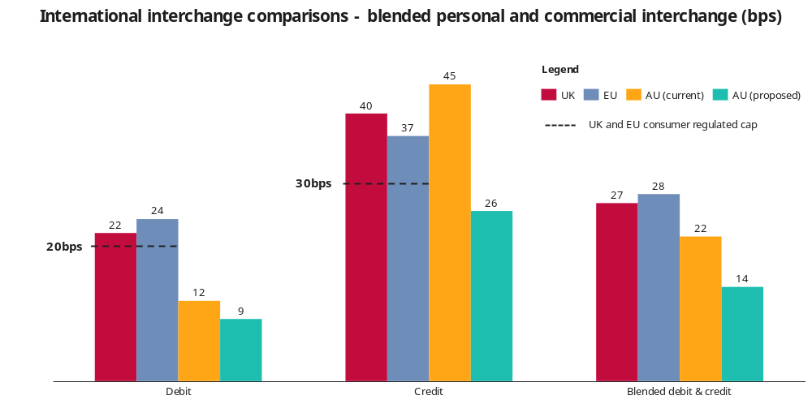

We acknowledge that different methodologies may create slightly different results. We are confident, though, that aggregate interchange levels in the UK and Europe are materially higher than proposed levels.
Contrary to the view in the Consultation Paper that the proposed reductions “…. would bring credit interchange fees into line with jurisdictions such as Europe and the United Kingdom,” the interchange caps proposed will see Australia as an outlier globally on both debit and credit interchange – ~60% lower than UK/Europe on debit and ~30% lower on credit.
In comparing Australia with the UK and Europe, we make two further observations. First, Australia is a much smaller market – Australia has ~40% lower card turnover than the UK and ~80% lower than Europe due to our smaller population. Given scale effects, it would not be unreasonable to expect higher interchange levels in Australia.
Second, Australia is unique in the extent to which ‘strategic interchange’ is applied at the discretion of the schemes. In most other markets, but not in Australia, differing rates are developed by industry or category.
In Australia, the combination of highly skewed pricing and a regulated aggregate cap means that smaller businesses attract higher interchange. Today, some eCommerce giants pay 90% less interchange than a small, in-person merchant, despite operating in the higher-risk online environment. CBA’s alternative interchange proposal will focus on reducing the level of dispersion to better distribute interchange costs and lower the costs for small businesses.
Detailed international market interchange cost breakdown
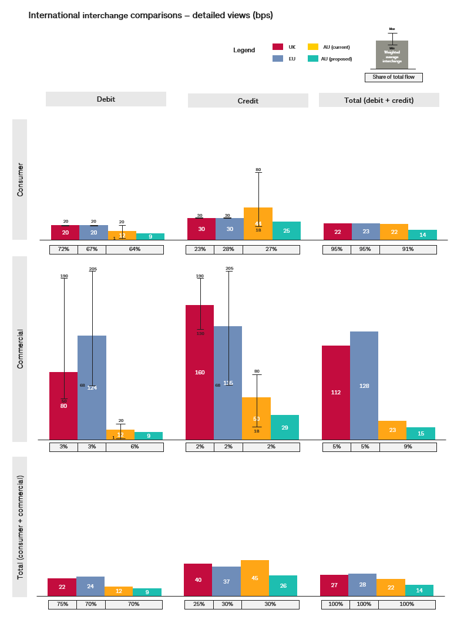

COST STUDY INCLUSIONS
The RBA first adopted a definition of eligible costs for calculating the cost-based benchmark for interchange in 2002. This definition was intended to capture costs borne by card issuers that should be passed on to merchants in the public interest. There have been a number of changes to the eligible cost categories in the 2025 Cost Guidance when compared to ‘eligible costs’ in in the 2005 Guidance.
The RBA states that “eligible costs should be limited to those that would be unavoidable in the provision of card network services to merchants”. Given the dramatic changes in card payments in the last 10 years, it would be reasonable for the RBA to consult on the continued relevance of each eligible cost category, as well as consideration of new categories to reflect the changing context.
There are two areas of cost that have been excluded from in 2025 but were included previously: disputes and chargebacks, and the cost of funds (interest free period). Further, the inclusion of a new category in 2025 relating to ‘Product Development’ has meant that some costs may have been miscategorised.
We broadly agree with the list of excluded costs – including that cardholder rewards should not be included. We note, however, that capital ratios have increased by more than double since 2014 and the importance of operational capital has increased along with an increased focus on liquidity. Both points are relevant to costs related to interest free periods.
Included since 2005 Guidance and in 2025 | Included since 2005 Guidance but not 2025 | Always excluded
- Authorisation & Transaction Processing (incl. digital wallet)  - Fraud (incl. related card costs)  - Scheme Fees (Net) | - Disputes & Net Chargeback Write-offs  - Cost of Funds (Interest-Free Period)  - Product Development (incl. risk and resilience) | - Cardholder Reward Programs  - Account Setup, Overheads, Maintenance  - Card Production & Delivery  - Product Development (residual)  - Collections & Write-Offs  - Cost of Capital

We outline our specific concerns with specific cost categories below:
- Cost of Funds (Interest-Free period)
The cost study estimates the cost of interest free days as 12 bps for the market. We believe this is not correct for several reasons:
- First, it included a time period when the cash rate was abnormally low (2022). Applying the RBA’s three-year rolling time period today would result in a figure of 17 bps vs 11 bps for CBA.
- Second, it is based on the cash rate alone. CBA does not pay the cash rate to fund assets: we issue wholesale funding. The behavioural term for these loans is 5 years – and we match funds to mitigate funding duration risk. This term premium results in a further ~5 bps cost.
- Third, a bank is required to hold capital, hybrids and subordinated debt against any loan, and these capital levels have increased materially since 2005. The cost of capital associated with the interest free period adds a further ~4 bps.
- Fourth, banks are required to hold excess liquidity to meet potential outflows from credit cards undrawn balances, which increase the cost by a further ~0.5 bps.
- Fifth, customers default on their credit card drawn and undrawn balances. Based on the 2014-25 loss rate of CBA’s Australian credit cards, loan impairment expenses increase the cost by an additional ~4 bps. This cost has never been included, and we do not propose that it should be.
The first point above was always eligible in prior cost studies, and we believe should still be. The second, third and fourth points above were previously not included in the cost study. We believe that they should be, as they are real costs associated with the provision of this service.
With respect to cost of capital, we note that the 2002 RBA costs study said: “there would also be a logic in including the cost of capital held against operational risk … however the Reserve Bank found the systems for measuring capital held against operational capital are immature compared to other costing systems … for these reasons, the Reserve Bank has concluded that this item is not appropriate for inclusion”.
Since this time, APRA has clarified and standardised the calculation and treatment of operational risk capital, and its allocation to business units, through APS115 (2021). Not including these costs for interest free balances is inconsistent with their treatment in the prudential standards.
The Commonwealth Bank recognises that there are valid arguments on both sides as to whether consumers or merchants should bear the cost of interest free periods. However, given the related risk of advantaging three-party schemes, we believe if interest free periods are still going to be excluded, this should not occur before the PSRA is in force and interventions are agreed to address the arbitrage.
Further, we would make the broad observation that where costs are not included, those services over time will likely be withdrawn without a sustainable economic model.

- Disputes and net chargeback write-offs
Unlike interest free periods, there is no reference to, or explanation in either the Consultation Paper or Cost Study information on why this material cost category has been changed to ‘non-eligible’ in the 2025 study. It was historically considered eligible.
We agree that debt collection activities should be excluded, as should credit write-offs. However, write-offs of chargebacks associated with disputed transactions should be eligible.
When a customer pays with a card, they have several protections in the rules of the payment scheme. These protections benefit both the consumer and the merchant. A streamlined dispute process benefits the merchant through trust that underpins the sale, particularly in the higher risk eCommerce environment.
Every year, the Commonwealth Bank mediates disputes between customers and merchants across millions of transactions. We collect information from the customer, send that to the merchant, collect the response and work out who is at fault. It is an especially costly exercise to mediate the dispute when the merchant and consumer disagree.
It costs the Commonwealth Bank tens of millions per year to perform this activity. The volume has risen by more than double in the past three years given the prevalence of disputes from online payments and big tech in particular. These costs were previously considered essential but have been excluded from the analysis presented to the PSB. The Commonwealth Bank believes that the Consultation Paper should have explained the rationale for this significant change relative to its previous practice.
Further, in the event that a customers’ physical card is stolen and used, the consumer is reimbursed and this cost is often borne by the Bank. It costs the Commonwealth Bank tens of millions per year to provide this protection to customers. These costs have always been and still are considered eligible.

- Product development
The 2025 Cost Study has a new ‘Product development’ category that is a ‘non-eligible cost’.
The definition of ‘product development’ in the template guidance gives EMV, tokenisation and 3DS as examples. The template then lists under ‘Fraud’, which is an eligible cost, “Card design and security features to reduce fraud (e.g. hologram, chip, tokenisation), and developing and maintaining systems and procedures for fraud prevention and detection. This ambiguity may have led to the exclusion of eligible costs by some institutions where costs were submitted inadvertently under an ineligible category.
In contrast the 2005 Guidance clearly explains measurement of eligible costs include direct software, hardware and other capital expenditures under each eligible cost category.
As the RBA has observed, reliance on electronic payment methods means that any disruption to the provision of these services (i.e. an outage) can have serious impacts on customers, businesses and the broader economy. Retail payments offerings have an average availability of 99.80 per cent or higher per quarter and card payments have the highest service availability.
The investments required to reduce risk and maintain resilience are significant and should be eligible. The Commonwealth Bank considers this is consistent with “broader policy considerations beyond cost recovery, in line with the PSB’s legislated mandate and longstanding practice of setting interchange regulations”. Given the geopolitical context, resilience is of particular importance and will require further investment.
Reliability benefits merchants directly, who want to ensure they can serve their customers when they want to be served. Some of our most significant complaints from businesses result from issues in accepting card payments or elevated decline rates.

Suggestions to ensure accurate assessment of costs on an ongoing basis
The Commonwealth Bank believes that there may be opportunities to refine the way costs are estimated to future-proof the standards. We appreciate that the historical data for each cost is factual. However, in some cases historical data is not an accurate guide for the future. The Commonwealth Bank believes that the RBA should attempt to build in reasonably foreseeable changes to relevant eligible costs as part of their continued work on the Issuer Cost Study.
CBA has identified a number of areas that will drive increased costs over the next few years. These include:
- increased share of tokenised payments
- continued mix shift to card not present transactions

COST STUDY PROCESS
The Commonwealth Bank appreciates that the RBA has undertaken an Issuer Cost study to better understand the costs faced by issuers. It is critical to ensure that the interchange caps are set appropriately to ensure card payments remain efficient, competitive and safe, and to avoid having to review the caps in the near future.
However, we have a number of concerns with the process, which may have impacted the validity of the findings. Key costs that need to be considered in setting interchange have been excluded as outlined above, while others have been underestimated, potentially due to the data collection approach.
Timeframes and process
The RBA’s 2014 Cost Study, although undertaken to understand the resource cost of the overall payments system, provides a useful comparison of the extent of industry consultation and time needed to obtain reliable data. Time for consultation is particularly important when the cost categories are changing materially and definitions in some cases are not clear.
 | 2014 study | 2025 Cost study
Industry consultation on data collection methodology | 4 months | 3 weeks
Time provided to submit data (including extension/resubmission time) | 9 weeks | 9 weeks
Further industry consultation post data collection | Yes | No
Time from submission of data to publication of cost study findings | 6 months | 2 months
Total time taken for cost study | 12 months | 5 months
Time from publication of cost study findings to release of Consultation Paper with interchange proposals | 12 months | 0 months (released at same time)
Total time elapsed | 24 months | 5 months

Similarly, the industry commissioned study undertaken in 2019-2020 by The Initiatives Group, covering 3 major banks and 3 smaller issuers is instructive of the consultation and time required to collect standardised and consistent data from issuers. We understand that study involved extensive written guidance and direct support to institutions to assist them to allocate the costs in a way that aligns with relevant cost categories.
We note that the RBA “…drew on methodology used in previous cost studies for collecting data, with modifications…” for a number of reasons, including time constraints. Consultation on decisions to vary the previous methodology, such as the changes to the activities and costs for inclusion in each cost category would have helped to ensure the correct data was obtained.

ECONOMIC MODEL AND ASSUMED BENEFITS
It has been stated that the proposed changes to surcharges “could save consumers a total of $1.2 billion each year”, and changes to interchange “could save businesses around $1.2 billion in interchange fees a year and make 90 per cent of businesses better off”. We do not believe that these assumed benefits will materialise for consumers or Australian businesses.
As the Consultation Paper notes, modelling of costs and benefits in the paper does not consider the responses by market participants in its determination of assumed benefits. These effects are important to consider when setting policy, particularly when the changes are material.
The Commonwealth Bank has engaged Mandala Partners to model the costs and benefits, taking into account these second-order dynamics. With their help, we have looked to precedent in other markets, and from prior interchange changes in Australia to inform assumptions.
The modelling shows that under the proposed interventions, consumers will be worse off as they face higher rates and fees, less access to credit, and loss of benefits including rewards. These costs more than offset any benefits from banning surcharging, which we estimate based on experience in other markets will be largely passed on by merchants incorporating payments costs in their end consumer price. Some merchants will be unable to pass on these costs and will experience reduced margins.
Further, small businesses will be worse off as regulated card interchange reductions are not passed on by acquirers, card mix shifts to more expensive unregulated payments, and small businesses lose the benefits of commercial cards that play a key role in their management of working capital.
Almost all of the costs will be borne by the domestic card issuers. These are the entities that fund the domestic infrastructure, risk, regulatory and operational costs of the system. It will be these entities that will need to support the national agenda in the event of a crisis.
More notable are the unintended beneficiaries of this policy. The three-party schemes have no wholesale cost to regulate, and there is no certainty of regulation under the newly amended PSRA. They are likely to be the single biggest beneficiary, extracting an extra $370-650 million from the payments system, largely from businesses paying higher payments costs as more consumers and businesses use these methods.
Merchants will be less able to cease acceptance of three-party schemes as they attract high spending customers and small businesses who seek frequent flyer or other awards points. This growth will accelerate as domestic issuers of regulated credit and charge cards degrade propositions to support unit economics as outlined above.
Acquirers that don’t pass on interchange savings will also benefit. These will predominantly be global acquirers that focus on small business given that they bundle pricing.
Profitability for schemes and digital wallet providers will be preserved and are likely to further expand. Digital wallet providers represent a growing and new source of cost to an issuer. They contribute indirectly to merchant costs without the scrutiny that interchange faces, and there is no effective competition that might drive these costs down due to technical and other constraints. Some digital wallet providers will absorb a larger and very material share of the interchange revenue cap for credit transactions.

Assumed benefits from changes proposed in Consultation paper (per annum)
 | RBA proposal:  Direct impacts – from Consultation Paper | RBA proposal:  Including modelled second order impacts
 | $ million | $ million
Cardholders
- Consumers | +1,225 | -200 to +5
- Commercial | +1,225 | +45 to +60
Merchants
- Small merchants | +185 | -25 to +10
- Larger merchants  >$10m in card transactions per year | -260 | -25 to +65
Payments industry
- Domestic issuers | -880 | -730 to -595
- Acquirers | - | +185 to +220
- Card networks – 4 party | - | +110 to +145
- Card networks – 3 party | - | +370 to +650
- BNPL | - | +90 to +175

We describe below further detail on the implications for various parties in the value chain.
i) Public benefit – consumers and small businesses
We do not believe that the estimated benefits to consumers will be realised. Based on Mandala analysis, consumers could be $200 million p.a. worse off to $5 million p.a. better off.
Merchant price increases are likely to offset the removal of surcharges. There is limited evidence that lower interchange will be passed on through lower prices. The proposed credit interchange reductions will put at risk the flexibility in interest-free days, low interest, and comparable (or lower) annual fees to the EU and US that Australians currently enjoy. For example, interchange reductions in the US were followed by reduced access to fee-free accounts, and ‘contributed to an increase in the unbanked population of approximately 1 million people, mainly among low-income families’.
With average credit interchange reduced by ~40%, low cost credit propositions for consumers and small businesses, and charge cards for all businesses, will be unviable, and these customers may turn to alternatives that are more costly for merchants such as three-party schemes, BNPL and payday lenders.
Other working capital options would also be more expensive for businesses. It could cost a median mid-to -large sized merchant ~80 bps to fund a month’s working capital facility, and for smaller merchants ~120 bps. Cards additionally come with extra benefits such as guaranteed settlement and lower operational overheads.
While we agree with the Reserve Bank that customer rewards should not be included in the cost study for setting interchange, they are relevant for calculating the net benefit to consumers as it is reasonable to assume that rewards programs will be reduced with a materially reduced economic model supporting card payments. As interchange reductions rely on acquirers passing on the savings, the benefit to small business is uncertain. The proposed changes, combined with the shifts outlined below will result in small businesses experiencing minimal benefits, if at all (potential range of $25 million worse off to $10 million better off).

ii) Three party schemes and BNPL
The reforms will benefit entities outside the RBA’s mandate, most notably three-party card schemes and BNPL, but negatively affect the regulated entities in the payments market. We estimate three-party schemes will benefit by $370-650 million p.a. from the intervention, and BNPL an estimated $90-175 million p.a.
The RBA’s conclusions from the 2021 Review remain relevant today: “In relation to the credit card benchmark, a further reduction could provide an advantage to both the three-party card schemes and other three-party systems such as BNPL arrangements; this is because these arrangements are not subject to the Bank’s interchange regulations, which allows them to fund more benefits for consumers through higher merchant fees. The benefits from lower interchange rates on credit card transactions might therefore be offset by a longer-term shift towards more costly three-party systems.“
It is still unclear exactly how powers under the updated PSRA would be used to address the regulatory arbitrage.
Credit interchange proposals will significantly impact the ability of regulated Australian institutions to compete with the premium cards of global three-party schemes that are currently unregulated under the PSRA. In its 2016 Review the RBA refrained from further reductions in credit interchange in part due to concerns about this risk.
The current Review has only referenced competition concerns in relation to commercial cards. As three-party schemes have 14% market share of personal credit cards, the implications for competition in both commercial and consumer credit cards should be considered.
The implications for the commercial card market, of which three-party card schemes have around a 50 % share be even more pronounced. As four-party corporate cards are almost entirely funded by interchange, a reduction to the extent proposed will threaten their viability. CBA believes that the estimated costs of issuing commercial credit and charge cards are not correct.
The most recent data published by the RBA showed that the share of three-party schemes in the total value of credit and charge card transactions had increased by around 8 percentage points between 2020 and 2024, to 23 per cent. This was the highest ever recorded market share and we believe is in large part due to the regulatory arbitrage that exists today and will be significantly amplified by the proposal.

Three party share of credit and charge card purchases
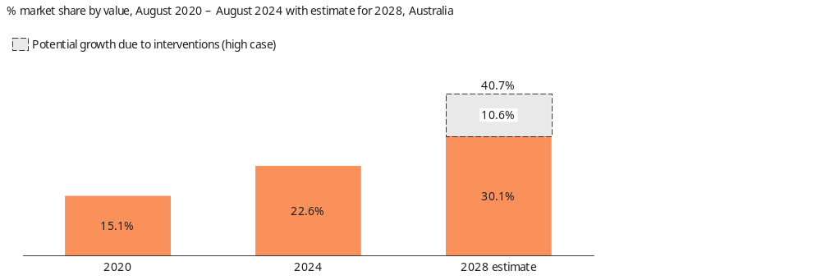

There is clear evidence that American Express is a ‘must-accept’ card for both consumer and commercial credit cards. It is accepted by 95% of Australia’s top retailers and acceptance has grown dramatically since 2022. These customers are overwhelmingly affluent, and attractive to businesses.
The RBA has previously acknowledged that “…lower interchange rates on credit card transactions might therefore be offset by a longer-term shift towards more costly three-party systems.“
With fee-regulated credit less attractive and available, customers will shift to three-party schemes. This will increase merchant fees (Average merchant fees according to RBA analysis: American Express 1.3% and BNPL ~3.5% compared to debit cards 0.4% and credit cards 0.8%).

iii) Global Acquirers
The economic modelling would see a $185-220 million p.a. benefit delivered to acquirers, heavily skewed towards global acquirers.
Global acquirers have become a feature of the Australian card payments landscape. CBA internal data shows that these participants have grown well above system over the last two years. This growth is most concentrated in industries that surcharge at higher rates for both in-person and online acquiring, and where pricing is more likely to be bundled with other services which obscures the wholesale cost.
Small businesses are heavy users of single-rate acquiring plans, which will be unaffected by interchange regulation unless acquirers choose to pass on the reduction. In the EU, acquirers passed on only 50% of their net cost savings to merchants and in the UK only 12%.
Although the PSB expects Payment Service Providers to pass on savings to merchants, we note the experience in Canada, where a multinational e-commerce payments processor declined to pass on savings despite the clearly stated expectations of the federal government.

ALTERNATIVE PROPOSAL
As we have described, we agree that debit and credit surcharging should be eliminated. However, we do not agree with the proposed changes to interchange. As outlined earlier in this paper, we believe these changes would make Australia a global outlier, do not include material relevant costs, and will not deliver the assumed benefits for Australian consumers or businesses.
The Commonwealth Bank has developed an alternative package of proposals in response to the PSB’s request for variations of the preferred package that would yield higher net public benefits.
We have applied the following principles in its design after consultation with key stakeholders:
- Maintain interchange cost outcomes among the lowest markets globally, namely the EU and UK,
- Deliver relief to small businesses, and
- Better distribute the economic impacts of market intervention across the value chain.
We have sought to find more targeted measures to achieve the RBA’s objectives because of the uncertainty of interchange reductions indirectly ‘trickling down’ to merchants.
The proposal consists of four components that are intended to be considered collectively and implemented together, and would require support from both the industry and the RBA:
- A fairer deal for small business on card interchange by limiting the discount available to big business to 30% of the underlying transaction rate rather than the 60%+ they enjoy today, so that small businesses don’t pay more than their fair share of interchange.
- Give small businesses a step up with a simple plan that includes POS software solution, for four party scheme debit and credit in store (card present) payments that make up the majority of small business transactions.
- Give businesses greater transparency and a marketplace to find a better deal with their provider or another. To be successful, a marketplace would need to be designed in close collaboration with small business and supported by the RBA’s powers. This initiative was suggested to CBA by COSBOA to address complexity and improve price discovery.
- Target fraud with mandatory strong customer authentication (SCA) for all online card payments to bring down payment system costs.

A fairer deal for small business on card interchange
Australia is unique in the extent to which ‘strategic interchange’ is applied at the discretion of the schemes. In most other markets, differing rates are developed by industry or category. The combination of highly skewed pricing and a benchmark means that smaller businesses attract higher interchange.
We believe that there may be simple changes to interchange regulation that could create a more sustainable playing field between large and small merchants, without the undesirable effects on competition between different card issuance models.
In particular, the RBA should consider regulating to prevent the hierarchy of categories in interchange schedules being used in ways that disadvantage small merchants. This could involve:
- Shifting strategic interchange for both debit and credit from an overriding priority to a discount to the underlying transaction, and limiting that discount to 30%.
- Implementing specific credit interchange caps to deliver a better distribution in favour of small businesses, and which are more reflective of costs. We propose separate caps for personal in-store (35 bps), personal eCommerce (80 bps), and corporate in-store (80 bps), corporate eCommerce (115 bps) transactions.
- Maintaining the existing benchmark for credit and debit given that Australia already has interchange levels below the UK and EU (see section 1), and to minimise impacts on smaller issuers and on investment in payments infrastructure.
These changes will deliver lower interchange to small businesses, particularly those that currently surcharge, while maintaining the current level of investment in the Australian payments system. The differentiated caps aim to reduce the level of dispersion within interchange fees in the Australian market, better reflect the cost of higher risk and complex transactions, and are consistent with the RBA’s user pays approach. For example, the card present market is mature, while eCommerce is where risk is concentrated and continued investment is required to meet rapidly evolving technology and customer needs.
Creating a corporate rate with a higher cap would support sustainability of four-party commercial and charge card offerings and provide some relief to the competitive disparity between regulated four-party offerings and the three-party schemes where it is most acute. It would also ensure continued low-cost access by businesses to working capital.
As noted above, simply lowering caps and eliminating the benchmark for credit could render the issuance of a variety of four-party cards largely unviable. Doing so would come at the cost of exacerbating the distortion between regulated four-party card issuance and unregulated three-party schemes.
Accordingly, to reduce the higher rates paid by small merchants, we believe the best starting point is to flatten the interchange hierarchies. We believe the best way to achieve this would be to limit the discount that is permissible in strategic merchant contracts, as proposed above.
Using MasterCard and Visa credit card schedules as an example: if a basic, non-rewards credit card is used in a standard, card-present retail transaction, a small merchant and ‘strategic’ merchant pay the same (approximately 20 bps) but when a high-rewards premium card is used, the small merchant will today pay an interchange rate that is around 60 bps higher than the interchange paid by the most-favoured strategic merchant (80 bps versus 20 bps, approximately).

Provide small business a simple, standard, all-in-one plan
In order to deliver value to small businesses that do not want the complexity of ‘interchange plus’ pricing, we believe the industry is better positioned than the regulator to develop a simple lower cost offering.
We envisage a plan that any acquirer could offer, with minimum capabilities endorsed by the small business community.
Alongside the interchange proposals outlined above, CBA could offer an acquiring plan with features tailored to small business needs and available to small businesses :
- Fixed single-rate merchant service fee (MSF), much lower than our current market-leading offer
- Accepts all in-store (card present) four-party scheme debit and credit cards
- Includes point of sale (POS) software
- Bring Your Own terminal
This proposal will be possible if interchange benchmarks are retained as proposed and the disparity between small and large business interchange is reduced.

Give businesses transparency and a marketplace to find a better deal
We agree with the RBA that “…greater transparency of acquirer’s pricing could…support competition between acquirers, including by empowering merchants to seek a better deal.” We have prepared a prototype disclosure in this submission and are committed to working with the banking and small business industry groups to align to a standard set of disclosures to support merchant transparency.
COSBOA has highlighted the complexity faced by small businesses in knowing which provider or product to choose. They have advised that a marketplace for card acceptance solutions would help small businesses compare pricing across providers. The data gathering and standardisation required for such a marketplace could be supported by an RBA standard or the Government could designate merchant services under the Consumer Data Right (CDR) regime.
The Commonwealth Bank would be willing to help fund such a solution for the small business industry or Australian Small Business and Family Enterprise Ombudsman to operate. If others are unwilling to contribute, we would consider funding this in its entirety.

Targeting fraud with Strong Customer Authentication
To continue to drive sustainable payment economics, while also reducing total system costs, it is important that policy interventions target the areas that drive cost into our payments system. One such area is fraud. The vast majority of the fraud losses are concentrated in online (card not present) transactions.
Strong Customer Authentication (SCA) is an additional level of authentication designed to make electronic payments safer. Europe mandated SCA standards alongside interchange interventions, with enforcement live since 2021. Australia has not progressed on whole-of-market fraud requirements since the application to the ACCC to mandate 3DS failed in 2016. In Australia SCA is voluntary, or subject to industry self-regulation for merchants with high online fraud rates.
With enhancements to technology that have lowered implementation costs and customer friction, Commonwealth Bank supports stronger whole-of-market SCA standards for online transactions that will reduce fraud in card payments and with it the associated costs of fraud and dispute management by all participants in the ecosystem.

Further thoughts on the PSRA
The Commonwealth Bank welcomes Parliament’s recent decision to pass the PSRA into law.
To be effective, the RBA’s powers must be applied across the value chain. The RBA now has the remit to address the potential risks to efficiency and competition in relation to three party schemes, BNPL and digital wallets that the RBA has previously identified.
The Consultation paper notes that the reforms to the PSRA would bring three-party networks clearly within the regulatory perimeter, stating “This is a significant development, that would enable the RBA to consider taking regulatory action under the PSRA if efficiency or competition issues were to arise involving the three-party networks.”
However, achieving this outcome will require expanded powers under the PSRA to be used to limit the extent of the regulatory arbitrage. The RBA has not indicated in the Consultation Paper that it has any concerns about efficiency or competition issues involving three-party networks. The proposed regulatory pathway to regulate three-party networks to deal with these concerns is also unclear.
Following commencement of the PSRA the RBA will be empowered to obtain the necessary information to undertake a comprehensive assessment of three-party schemes and consider appropriate intervention. As three-party schemes are already within the scope of this Review, a separate consultation under the amended PSRA should not be required.
CBA believes that it would be highly problematic to make regulatory changes that are certain to have significant effects on the competitive landscape without confirmation of how the RBA will use these additional powers to deal with the specific problem of competitive neutrality.

Summary
CBA’s alternative approach delivers on the RBA’s mandate for safety, competition and efficiency. It creates pricing certainty and relief for consumers and savings for small businesses, and will continue to deliver interchange cost outcomes below the EU and UK.
It avoids adverse unintended consequences such as driving growth of high-cost three party schemes and benefiting global companies at the expense of investment into domestic payments infrastructure, and threatening the viability of small issuers. Large businesses will pay more for regulated payments than they do today. But there will not be a shift in payment mix towards higher-cost unregulated payments.
In this way, we believe that the economic impacts of market intervention will be better distributed across the payments value chain and economy, yielding higher net benefits in the national interest.
We believe that this approach better meets the RBA’s objectives than the proposed interventions once second order effects and foreseeable competition responses are considered. We estimate that this proposal will leave small businesses better off – delivering $440-520 million in value p.a. after accounting for any adverse surcharging effect.

Assumed benefits from changes proposed in Consultation paper (per annum)
 | RBA proposal:  Direct impacts – from Consultation Paper | RBA proposal:  Including modelled second order impacts | CBA alternative proposal: Including modelled second order impacts
 | $ million | $ million | $ million
Cardholders
- Consumers | +1,225 | -200 to +5 | -135 to +145
- Commercial | +1,225 | +45 to +60 | +70 to +85
Merchants
- Small merchants | +185 | -25 to +10 | +440 to +520
- Larger merchants  >$10m in card transactions per year | -260 | -25 to +65 | -490 to -245
Payments industry
- Domestic issuers | -880 | -730 to -595 | -25 to -15
- Acquirers | - | +185 to +220 | -10 to +45
- Card networks – 4 party | - | +110 to +145 | -
- Card networks – 3 party | - | +370 to +650 | +40 to +65
- BNPL | - | +90 to +175 | +15 to +30

Where to from here?
We see a clear pathway for the RBA to finalise and implement changes to interchange in a way that is supported by robust cost analysis and consideration of the RBA’s expanded remit under the updated PSRA.
Proposal | Timing | Comments
Refine issuing cost study | Prior to 26 November 2025  (PSB meeting) | Time should be allowed for constructive challenge between the RBA and industry, and further data collection and analysis to better reflect market changes over the past 10 years, the current context, and to create clarity and consistency on new cost study category definitions.
Propose potential interventions under the PSRA | Q4 2025 | RBA to provide guidance on potential interventions under the PSRA so that the new powers can be exercised promptly following the commencement date (three months from Royal Assent).
Finalise policy proposals | Q1 2026 | Based on the above and current consultation, refine policy proposals to ensure policy objectives are met, taking into account second order implications.
Amendments to surcharging rules | 1 July 2026 | Introduce transparency measures and a small business plan with the ban on surcharging to help small businesses seek a better deal.
Additional merchant level disclosure | 1 July 2026
Credit interchange levels adjusted | After PSRA enacted | Synchronise any changes to credit interchange levels with the implementation of PSRA actions unless competitive disparity concerns are discharged in the course of above.

This roadmap for reform will give the market the clarity on regulatory settings it needs to drive productive change. It will minimise the risk of irreversible market distortions from applying regulation to some payment systems but not to others until action can be taken under the modernised PSRA legislation.

APPENDIX A: EXAMPLE MERCHANT DISCLOSURE STATEMENT
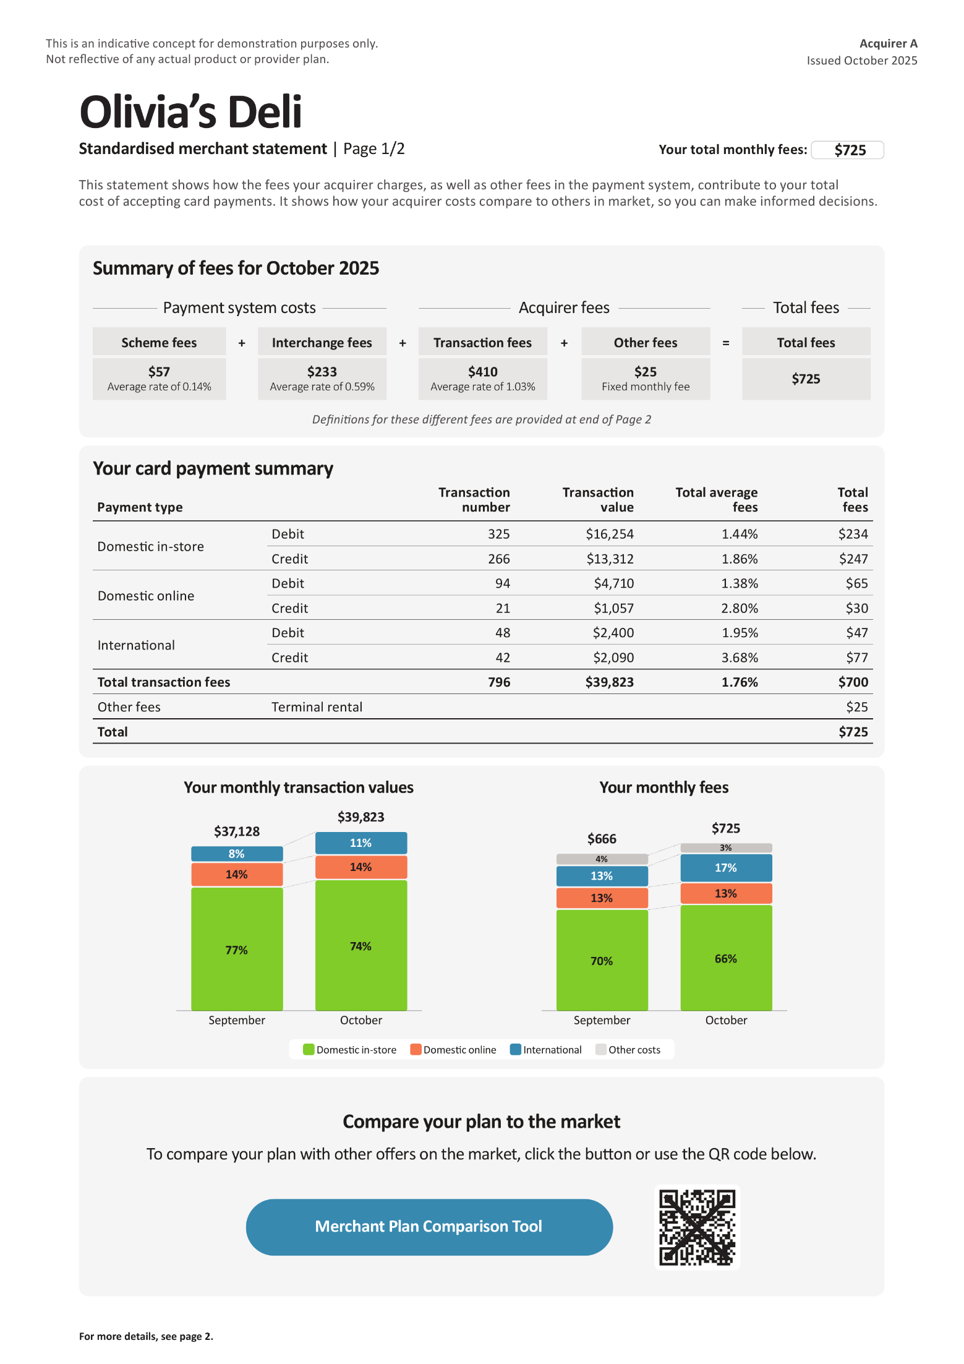

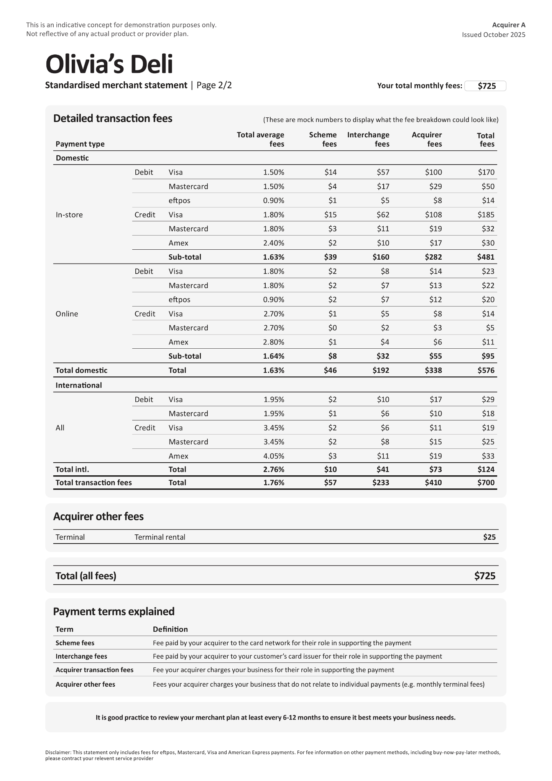

APPENDIX B: EXAMPLE ACQUIRER COMPARISON SITE
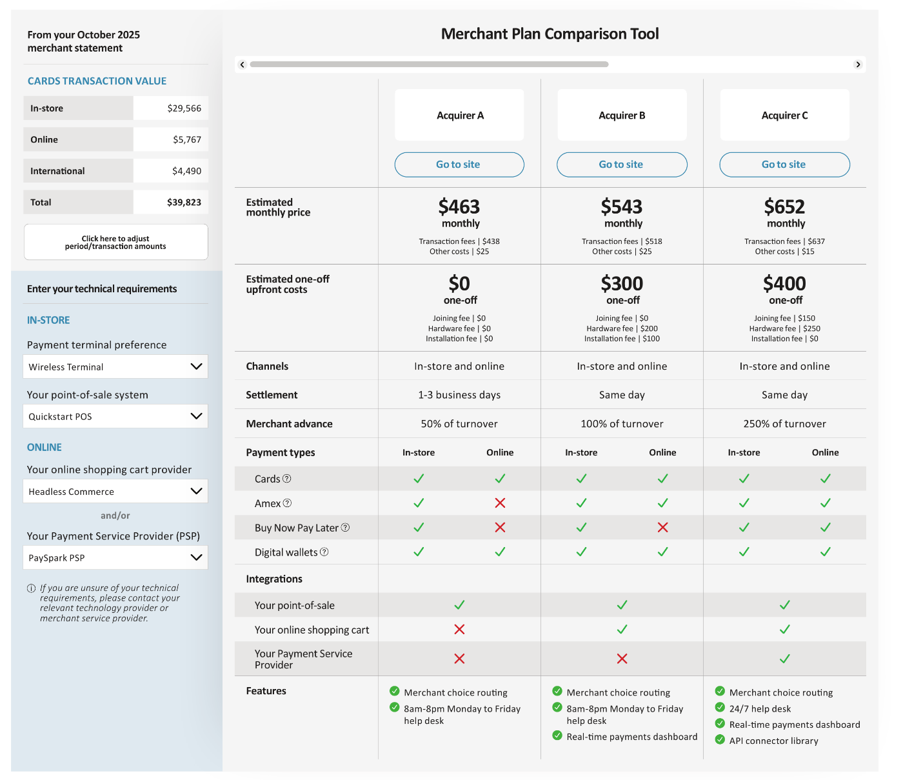

APPENDIX C: AUSTRALIAN POLICY CHANGES FOR CAPITAL REQUIREMENTS SINCE 2002
In 2002 the Reserve Bank defined eligible issuer costs and excluded several “costs of capital,” citing contemporaneous prudential practice and measurement capability. Since then, APRA has introduced updated standards for credit, operational and liquidity risk (e.g., APS 113, APS 115, APS 210), and ADIs’ Pillar 3 disclosures provide consistent, auditable measures of these risks at the product-portfolio level. This evolution warrants revisiting the 2002 positions to ensure consistency across Australian policy settings affecting ADIs.
Capital | 2002 Position | Subsequent Changes | Implications for Eligibility
Cost of capital held against credit risk | The RBA concluded that capital held against credit risk on outstanding credit-card balances “arises directly out of the provision of revolving credit facilities to cardholders and … is appropriately recovered through the interest rate charged on these facilities” [RBA 2002, p. 37]. | - APRA framework. APS 113 require capital for both drawn balances and undrawn portions of retail revolving limits via estimated conversion factors.  - Empirical evidence. CBA’s Pillar 3 shows that a substantial share of undrawn credit-card limits converts to exposure for capital purposes (approximately ~86% average credit-conversion on undrawn limits) [CBA Pillar 3 FY25, Table CR6].  - Business model reality. For transactor accounts (interest-free balances), this capital cost cannot be recovered through interest because no interest is earned on those balances. | A portion of credit-risk capital is directly attributable to providing card payment capability and undrawn commitments (independent of lending revenue). That portion is not recovered via interest on transactor balances and should be considered eligible in the cost-based benchmark. The materiality of this item has increased since 2002 alongside higher capital stack requirements (e.g., unquestionably strong CET1 plus materially larger Tier 2/LAC components).
Cost of capital held against operational risk | The RBA acknowledged it would be logical to include operational-risk capital “to the extent the risks arise out of the provision of services to merchants,” but excluded it because measurement systems were “immature” and varied widely [RBA 2002, p. 37]. | - APRA framework. From January 2021, APS 115 introduced a standardised measurement approach for operational-risk capital.  - Empirical evidence. CBA discloses operational-risk RWAs determined under this standardised approach, enabling consistent attribution to identifiable business activities, including card issuing [CBA Pillar 3 FY25, Section OR2]. | The 2002 rationale for exclusion no longer applies. Operational-risk capital attributable to card issuing can be measured on a consistent and auditable basis and should be considered eligible.
Liquidity cost of undrawn balances | Liquidity costs associated with undrawn retail commitments were not assessed for potential eligibility. | - APRA framework. From January 2014, APS 210 Liquidity Coverage Ratio (LCR) recognise contingent drawdowns on undrawn retail revolving commitments via prescribed outflow factors, requiring ADIs to hold high-quality liquid assets.  - Empirical evidence. CBA discloses LCR metrics that incorporate these contingent outflows for card limits [CBA Pillar 3 FY25, Table LIQ1]. | The cost of maintaining liquidity for undrawn credit-card limits is a direct consequence of offering card facilities and is not recovered on transactor balances. It should therefore be considered for inclusion as an eligible cost, measured using LCR outflow parameters and the issuer’s cost of funding.

Consultation Paper, page 26.
Calculated based on applying CBA’s transaction mix to UK and EU interchange tables for personal and commercial, debit and credit. Blended totals calculated using the aggregate transaction mix in each jurisdiction. Europe approximated by the average of France and Germany.
Consultation Paper, page 32.
AU current, UK and EU based on publicly available interchange tables, applied to approximate flows based on our estimates. EU approximated by France and Germany. ‘AU proposed’ estimated based on proposed reforms.
Issuer Cost Study 19 August 2025, page 3.
While we agree that customer rewards should not be an ‘eligible cost’, they are relevant for calculating the net benefit to consumers.
CBA analysis: Total capital required has increased further (18.25% vs 8%), given the higher LAC requirements.
Refer Appendix C for a summary of Australian policy changes for capital requirements since 2002.
Applying average RBA cash rate from FY23-25 to CBA’s cost study submission. Or, 18 bps using prospective 10-year swap rate.
RBA (2002) Reform of Credit Card Schemes in Australia - IV Final Reforms and Regulation Impact Statement, page 37.
Issuer Cost Study 19 August 2025, pages 20 and 21.
RBA Bulletin October 2024, The Reliability of Retail Payment Services, pages 32 and 34.
Issuer Cost Study 19 August 2025, Page 3.
The findings of the 2014 cost study (which covered issuers and other participants) were released in December 2014 in Stewart, Chan, Ossolinski, Halperin and Ryan (2014) The Evolution of Payment Costs in Australia, RBA RDP 2014-14.
Time taken from start of consultation to publication of findings.
Issuer Cost Study, page 3.
Media release - Review of Merchant Card Payment Costs and Surcharging, RBA, 15 July 2025.
Of 53 EU/UK issuers, 50% increased annual fees, 40% APR, and 20% other fees. (Payments Industry Intelligence; 2016).
~55% of small merchants indicated that they will raise prices, with ~60% raising by full amount of surcharge. (Mastercard Australia: AADF survey of smaller merchants n=627).
Consultation Paper, Table 9.
Modelling assumes that, of the $1,225m estimated in the Consultation Paper, the split is $1,060m for personal card holders and $165m for commercial card holders, using ABS income and card consumption data, 2020-2021.
Modelling assumes that foreign issuers have an impact of -$270m, as a balancing item from Consultation Paper, Table 9.
Excludes $25m one-time acquirer implementation costs referenced in Consultation Paper.
Julian Morris, Todd J. Zywicki & Geoffrey A. Manne (2022) “The Effects of Price Controls on Payment-Card Interchange Fees: A Review and Update”, International Center for Law & Economics White Paper.
Review of Retail Payments Regulation Conclusions Paper (2021) Page 39.
Review of Retail Payments Regulation Conclusions Paper (2021) Page 17.
Consultation Paper, page 35-36.
Consultation Paper, page 36.
Commercial cards are largely charge cards (no interest and cards paid in full each month), and commercial credit cards tend to have lower revolve rates so interest revenue is low.
RBA (2025) Payments Data, Table C1.3: Credit and Chage Cards – Market Shares of Card Schemes.
Statistics from August are used to reflect most recently available statistics on market shares, as the series was decommissioned in August. 2020 and 2024 figures sourced from RBA (2025) Payments Data, Table C1.3: Credit and Charge Cards – Market.
Review of Retail Payments Regulation Conclusions Paper (2021) Page 39.
Connolly (2024) Online Retail Payments – Some Policy Issues.
Acquirers passed through $1.2bn benefit after a $2.7bn interchange saving offset by a $0.3bn scheme fee increase (Source: European Commission 2020); Final Report: Market review into card-acquiring services, Payment Systems Regulator (2021).
https://finance.yahoo.com/news/lower-visa-mastercard-fees-small-113000078.html
In 2024, the fraud rate for domestic card not present (online) transactions was 9.3 basis points, more than 11 times larger than for card present (Fraud figures from Page 13 of AusPayNet Fraud Report 2025; total transaction values from RBA Payments Data, C1.1 and C2.1).
Subject to fair use policy (e.g. limits on international card mix) and detailed plan design including pricing.
Refer prototype in APPENDIX A.
Refer prototype in APPENDIX B.
AusPayNet Fraud Mitigation Framework.
Consultation Paper, page 37.
Same footnotes apply as referenced in table above.
Reform of credit card schemes in Australia IV, RBA, 2002

