Australian Restaurant & Cafe Association Ltd. (ARCA) Submission

Review of Merchant Card Payment Costs and Surcharging – Reserve Bank of Australia Consultation Paper, July 2025

Executive Summary-
Q1 – Removal of Surcharging on Designated Card Networks
Position: Oppose removal.
Removing the ability for restaurants and cafés to levy reasonable, cost-based surcharges would not serve the public interest. Instead, it would increase costs for small hospitality businesses, reduce transparency for consumers, and drive broad-based price increases.
Key points:
- Merchant fees are a material cost input for restaurants and cafés. In ARCA’s latest member survey, 81% of venues currently surcharge, primarily on card-present transactions, to recover these costs — a stark contrast to the RBA’s own figure (~10% across all merchants).
- If surcharging is banned, operators will have no choice but to embed these costs into menu prices, meaning all diners — including those paying with low-cost methods — will face higher prices.
- This outcome reduces price transparency and disproportionately benefits high-cost card issuers and large financial institutions.
Recommendation:
Retain surcharging rights. User choice, user pays-not the merchant.

Q2 – Interchange Regulation Changes
Position: Support proposed changes but could go further.
The proposed domestic debit benchmark of 6 cents and credit cap of 0.3% would:
- May lower costs for small merchants with limited negotiating power.
- May reduce cross-subsidisation, where smaller venues indirectly fund the low rates given to large retailers.
- Better align caps with true issuer costs, as per RBA cost studies.
If fee reductions are passed on, it would particularly benefit hospitality businesses with high transaction volumes and low-ticket values, delivering meaningful cost relief without undermining system functionality. The RBA can go further as small business still pay 6x big business on debit and 2x on credit in merchant fees.
Recommendation. Commence with lower interchange caps so savings flow immediately into the system and soften the impact of any subsequent changes to surcharging or pricing displays. Early interchange relief is essential to protect small, low margin venues.

Q3 – Considerations for Smaller Issuers
To ensure the benefits of interchange reform regulation must be consistent (no bigger interchange for small banks) & duel network cards must re-mandated for all banks to enable least cost routing. Plus we recommend;
- Pass-through enforcement: Mandate PSPs to pass on wholesale cost reductions in full.
- Anti-avoidance monitoring: Guard against increased scheme fees or altering bundled pricing.
- Mandatory LCR for all debit transactions (card-present and card-not-present) to enhance competitive pressure, requiring small banks have multi network debit cards.
- Strategic rate gap review: Prevent deep discounting for large merchants that distorts competition.

Q4 – Net Compensation Provisions
Position: Support amendments.
Extending net compensation provisions to issuers sponsored by overseas entities:
- Closes a potential regulatory loophole.
- Ensures competitive neutrality between domestic and foreign-backed issuers.
- Promotes market integrity by preventing circumvention via indirect payments.
Compliance should be readily achievable, as the RBA notes this reflects current practice.

Q5 & Q6 – Transparency on Wholesale Fees and Scheme Fee Simplification
Position: Strongly support both proposals.
Publishing segmented wholesale fee data:
- Gives small merchants visibility to benchmark costs.
- Encourages competitive pressure on PSPs and card networks.
- Supports informed decision-making and advocacy.
Simplifying scheme fee schedules:
- Removes an unfair complexity burden from small businesses.
- Enables effective LCR implementation.
- Increases transparency in distinguishing mandatory vs. optional fees.
Recommendation: Require card networks to deliver measurable simplification plans by 31 December 2026, with PSP and merchant group consultation. Without caps and clarity, opaque scheme fees can climb despite interchange cuts, pushing merchant COA back up.

Q7 – Expectation on Scheme Fee Increases
Setting an expectation for justification of scheme fee increases is helpful but insufficient:
- Transparency alone won’t stop unjustified increases — especially in the credit card market, where no LCR exists.
- Small scheme fee changes can have outsized impacts on hospitality profitability.
Expectations alone are not binding; add a comply or explain trigger if scheme fee growth outpaces expectations.

Q8 – Further Regulatory Measures on Scheme Fees
If unjustified growth persists:
- Cap scheme fees relative to transaction values, especially for credit and international transactions.
- Mandate dual-network credit cards and extend LCR to credit transactions.
- Require public reporting of average scheme fees by transaction type.
- Enforce pass-through obligations for PSPs.

Q9 & Q10 – Merchant Cost of Acceptance Publication & Statement Breakdown
Position: Support with refinements.
Publishing average cost-of-acceptance data:
- Creates benchmarks to drive negotiation and competition.
- Should be in a standardised, comparable format to allow “league tables” and sector benchmarking.
Adding domestic vs. international cost breakdown to statements:
- Highlights the higher cost burden of overseas cards.
- Supports pricing and acceptance decisions.
No public interest case exists for exempting specific industries — all sectors should be treated equally.

Q11 – LCR Implementation
Recommendation: Move from “expectation” to default-on dynamic LCR for eligible merchants in hospitality and other small business segments, with:
- Mandatory disclosure of LCR status and savings on merchant statements.
- Pass-through requirements for blended-rate plans.
- Annual public reporting of adoption and savings by sector.

Q12 – Assessment of PSB’s Preferred Package
Positive:
- Interchange cap reductions will benefit small hospitality operators.
- Transparency measures will improve market functioning.
Concerns:
- Removal of surcharging without pass-through enforcement risks certain net cost increases.
- “Expectations” without enforcement have a poor track record in delivering small merchant benefits.
Variations:
- Retain surcharging.
- Mandatory pass-through audits.
- Small-business-specific transparency obligations.

We recommend a sequenced implementation:
1. Reduce interchange caps.
2. Turn on transparency, simplification, LCR default on, and enforceable scheme fee guardrails.
3. Only then adjust surcharging settings (if at all).

Q13 – Implementation Timeline
1 July 2026 start date is not workable, and should be amended to 1 July 2027 if:
- Final standards are published by mid-2026.
- Merchants receive twelve months’ notice of exact rate changes.
- Transparency measures commence in 2026 to allow plan renegotiations before any surcharging removal.

ARCA supports a commencement no sooner than 12-18 months after final standards to allow repricing, software changes (POS/PSP), signage, staff training, and contract renegotiation.

Q14 – Draft Standards
Concerns:
- No enforcement of pass-through.
- No small-business-specific disclosures.
- Inadequate coverage of mobile wallet/online transaction fees.
- Complexity remains for owner-operators.

Conclusion
ARCA supports reforms that reduce costs, increase transparency, and promote fair competition in the payments system — but warns that without binding pass-through obligations, small business protections, and competitive pressure in credit markets, the intended benefits may not reach the hospitality sector.
We stand ready to work with the RBA, the PSB, and industry stakeholders to ensure reforms deliver a sustainable, equitable payments ecosystem for Australian restaurants and cafés.

About ARCA
The Australian Restaurant & Cafe Association Ltd. (ARCA) is a Member based not-for-profit Industry Association and is the strongest voice for the Restaurant & Cafe segment of the Accommodation & Foodservice Industry, representing a sector that employs 500,000 across nearly 56,000 restaurants & cafes in Australia. Our Members include many of the leading restaurants & cafes in Australia, which employ tens of thousands within the Restaurant & Cafe segment. The majority of the industry is considered small businesses with 99% of restaurants and cafes earning less than $10 million in annual revenue and 91.4% earning less than $2 million, according to the Australian Bureau of Statistics (ABS).

ARCA welcomes the opportunity to again provide input into the Reserve Bank of Australia’s (RBA) Review of Merchant Card Payment Costs and Surcharging Consultation Paper into Merchant Card Payments Costs and Surcharging. As the peak industry body for cafes and restaurants across the country, ARCA represents businesses that are directly impacted by the rising costs of card payments and merchant fees and are the single most affected segment around surcharging. We appreciate the RBA’s Consultation, which is timely given the ongoing concerns around the cost of living and the evolving preferences of consumers in the payments landscape.
As highlighted in the RBA Consultation Paper, Australian consumers benefit from the convenience and security of card payments, and these payment methods are now integral to the way businesses like ours interact with customers.

However, the increasing cost of doing business, including merchant fees, is becoming an ever-greater challenge for our members. This is particularly true for small and medium-sized businesses in the hospitality sector, which often operate on tight margins and have little leverage to negotiate better payment processing terms.

ARCA acknowledges that the RBA’s current regulatory framework, including initiatives aimed at reducing interchange and scheme fees, as well as the introduction of least-cost routing (LCR), has helped address some of these concerns. However, as the RBA has noted, it has been some years since the surcharging framework was introduced, and it is now essential to assess whether this framework is still fit for purpose. In an environment where the costs associated with card payments are rising, and consumer payment preferences are shifting, it is critical that the regulatory framework evolves to ensure that both businesses and consumers can benefit from fairer and more efficient payment systems.

In our submission, informed by extensive consultation with members and industry stakeholders, the Australian Restaurant & Café Association (ARCA) will highlight the ongoing challenges that restaurants and cafés face in managing the rising cost of merchant card payments. These costs remain disproportionately high for small hospitality businesses, exacerbated by limited access to strategic rates and bundled pricing models that obscure true payment costs.

We will also respond to the RBA’s proposed regulatory changes, including the potential removal of surcharges and the introduction of tighter interchange caps. While these reforms aim to enhance efficiency and fairness in the payments system, a critical concern for our sector is the risk that payment service providers may not pass through cost savings, effectively shifting more of the burden onto already strained small businesses. This risk is particularly acute in the café and restaurant segment of the Accommodation and Food Services industry, where high transaction volumes, low margins, and limited bargaining power make payment system design a material operational issue.

ARCA supports the RBA’s objectives to improve competition, transparency, and efficiency. However, we strongly urge that any changes ensure small merchants are not disadvantaged by the actions of larger market participants or by unintended consequences of reform. This includes guarding against cross-subsidisation, ensuring clear visibility of scheme and acquiring fees, and preserving flexibility through measures like least-cost routing.
Our sector requires a payments ecosystem that reflects the realities of small business operation: transparent, low-cost, competitive, and adaptable to emerging technologies. We welcome the RBA’s consultation and look forward to working collaboratively with policymakers and industry stakeholders to deliver reforms that create a more sustainable and equitable future for Australia’s hospitality sector.

Q1: Would removing surcharging on designated card networks best support the RBA’s objectives to promote the public interest through improving competition, efficiency and safety in the payments system?
No — removing the ability for restaurants and cafés to apply reasonable, cost-based surcharges would not support the public interest. In fact, it would increase pressure on small hospitality businesses, reduce price transparency, and lead to higher base prices for all consumers.
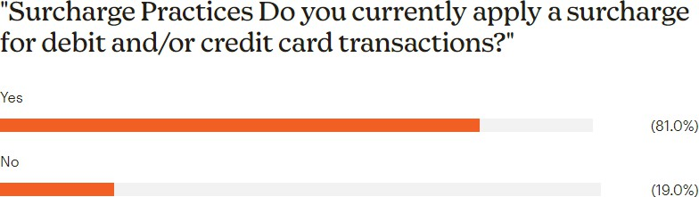
For restaurants and cafés — often operating on margins of 3–5% — merchant fees are a significant and rising cost. Based on ARCA Member & Industry Surveys, over 81% of venues charge diners a surcharge, in stark contrast to the RBA’s figures (approx. 10%) and the right to do so allows small operators to recover the cost of card acceptance, particularly for premium cards or delivery orders. If this right is removed, businesses will have no choice but to embed these costs into their menu prices, impacting all diners regardless of payment method. A recent ARCA Member survey indicated:
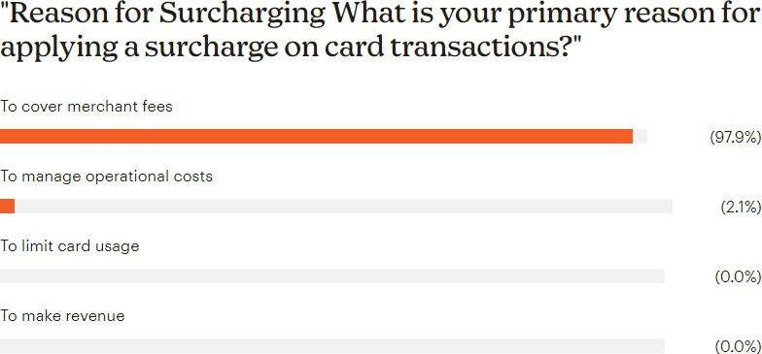
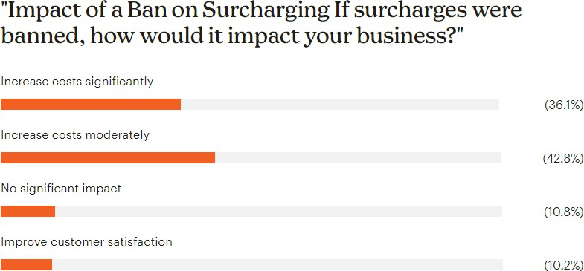
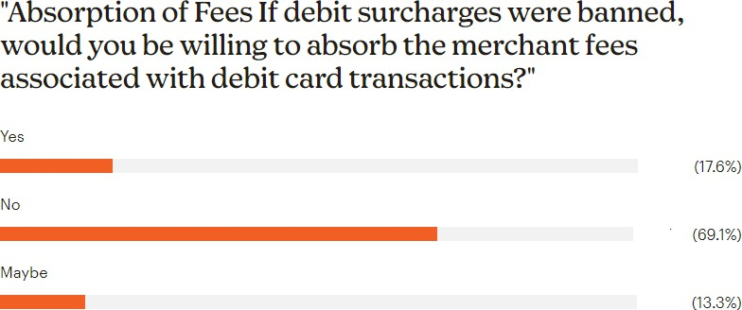

This outcome is less transparent and less fair for the public than the current surcharging framework.
The RBA's claim that eliminating surcharges would promote efficiency ignores the realities faced by low-margin, high-volume industries like hospitality. The supposed “consumer savings” will likely be negated by broad-based price increases. Furthermore, removing surcharges disproportionately benefits large financial institutions and high-income credit card users, while placing the burden on small businesses and everyday Australians.
Rather than removing the surcharging framework, ARCA recommends:
- Retaining surcharging rights with a refined definition of acceptable costs (focused on transparency and enforcement),
- Supporting merchant fee reductions through interchange caps or competitive payment reforms,
- Educating consumers and businesses on payment choices and costs, and
- Exempting small businesses from any surcharging ban to protect fairness and viability.
Restaurants and cafés are not financial institutions — they cannot absorb rising merchant fees indefinitely. If surcharges are removed, the result will be higher prices, lower transparency, and weaker competition — precisely the opposite of the RBA’s stated Q2: Do the proposed changes to interchange regulation promote the public interest by improving competition and efficiency in the payments system?
Recommendation:
Retain surcharging rights. User choice, user pays-not the merchant. Card acceptance cost is not a shared overhead like rent or water; it is triggered by a customer’s card and channel choice (for example, international credit cards vs eftpos/debit, phone/online vs in person). Removing cost based surcharging forces cash or debit paying and in person patrons to cross subsidise higher cost credit and card not present (CNP) payments.
Because card type and channel materially change acceptance costs, removing surcharging effectively replaces a targeted, avoidable fee with higher prices for all customers and reduced service quality.
CNP transactions such as phone orders and online orders for delivery or pick up remain structurally higher cost under the PSB’s proposals, and merchants are typically liable for fraud and chargebacks in these channels. These options are offered for customer convenience but reflect a consumer choice that drives incremental cost for venues. Removing cost-based surcharging would force in person cash or debit payers to subsidise higher cost CNP transactions. To avoid this distortion, the framework should:
(a) retain cost based surcharging and permit channel specific surcharges that reflect actual cost of acceptance (COA); and
(b) require dynamic least cost routing (LCR) so merchants can steer to lower cost options online as well as in store.
Q2: Do the proposed changes to interchange regulation promote the public interest by improving competition and efficiency in the payments system?
Yes, but could go further, from the perspective of restaurants and cafés, the proposed changes are in the public interest as they help reduce payment processing costs and promote a fairer, more competitive system:
- Lower costs for small businesses: Small merchants, including most restaurants and cafés, currently pay significantly higher interchange rates than large merchants due to their lack of negotiating power. Lowering the domestic debit benchmark to 6 cents and capping credit interchange at 0.3% will help reduce this imbalance and deliver real cost savings for small businesses.
- Reduced cross-subsidisation: The current system sees smaller hospitality businesses effectively subsidising the payment costs of large retailers. These changes would reduce that unfair burden.
- Better alignment with true issuer costs: The RBA’s own cost studies show that the proposed caps still exceed the actual average issuer costs. This ensures efficiency is improved without compromising the functionality or innovation of the payments system.
- Support for cost-of-living relief: Reducing hidden card payment costs for restaurants and cafés can help ease the price pressures faced by consumers, improving access to affordable dining experiences amid a cost-of-living crisis.
- But we recommend that the RBA could go further as small businesses still pay 5x what big businesses pay on debit cards and 3x on credit cards in merchant fees.
Recommendation. Commence with lower interchange caps so savings flow immediately into the system and soften the impact of any subsequent changes to surcharging or pricing displays. Early interchange relief is essential to protect small, low margin venues.

Q3: Are there further considerations for smaller issuers that the RBA should take into account to enhance competition and efficiency in the payments system?
Yes. While supporting the reduction in interchange rates, restaurants and cafés believe the RBA should ensure that:
- Savings are passed through to merchants: The RBA must implement transparency requirements and enforce PSP accountability to ensure any interchange fee reductions are fully passed through to restaurants and cafés in the form of lower merchant service fees.
- No anti-competitive behaviour by card schemes or large banks: There should be strong monitoring for attempts to circumvent these changes through increased scheme fees, bundled pricing, or discriminatory treatment of small merchants.
- Support for least-cost routing (LCR): Mandatory enablement of LCR for all card-present and card-not-present debit transactions should be fast-tracked, especially in hospitality, where margins are thin and contactless payments are high.
- Recognition of small merchant vulnerability: The RBA should further explore ways to narrow the strategic rate gap and consider setting a floor on interchange rates offered to large merchants to stop undercutting and distortion of fair competition.
- To ensure the benefits of interchange reform regulation must be consistent (no bigger interchange for small banks) & duel network cards must re-mandated for all banks to enable least cost routing.

Q4: Do the proposed changes to the net compensation provisions effectively achieve the RBA’s objectives and promote the public interest? Will Australian issuers sponsored by overseas entities be able to comply with the changes?
Yes, the proposed changes to the net compensation provisions are a necessary and appropriate step to:
- Close regulatory loopholes: Restaurants and cafés support ensuring that all Australian issuers, including those sponsored by overseas entities, are subject to the same rules. This avoids regulatory arbitrage and protects the integrity of the system.
- Ensure competitive neutrality: Equal treatment of all issuers—regardless of domicile—ensures a level playing field and discourages market manipulation that could ultimately increase costs for small businesses.
- Promote transparency and trust: Broadening the scope of net compensation provisions builds confidence among merchants that interchange reforms cannot be undermined through side payments or indirect compensation mechanisms.
- Compliance feasibility: The RBA notes that this regulatory gap is not currently being exploited and that the proposed changes reflect existing practice. Therefore, compliance should be achievable without disruption, particularly for well-governed institutions.

Conclusion:
Restaurants and cafés strongly support the RBA’s proposed reforms to reduce domestic and foreign interchange fees and amend net compensation rules. These reforms would deliver significant cost relief, reduce cross-subsidisation, and promote fairness in a payments system where small hospitality businesses have historically been disadvantaged.

Q5: Does the proposal for card networks to publish aggregate wholesale fee data achieve the RBA’s objectives of improving competition and efficiency among the card networks? Does the proposal adequately balance the information needs of the market with commercial concerns?
Yes, but needs to be per segment, not just aggregated—from the point of view of restaurants and cafés, the proposal strikes an appropriate balance and is a critical step toward greater fairness and efficiency in the payments ecosystem.
- Improves merchant visibility: Many small hospitality businesses lack the financial expertise, negotiating leverage, or access to detailed pricing information to assess whether they’re getting a fair deal. The publication of segmented interchange and scheme fee data, broken down by transaction type (card-present, card-not-present, mobile wallet, etc.), will allow restaurants and cafés to better understand the true costs of different payment types.
- Supports cost reduction through comparison: Segmented data would enable restaurants and cafés—especially through their PSPs or industry bodies—to compare costs across card networks and push for more competitive service offerings. This could encourage acquirers and PSPs to balance bundled merchant service fees or enable smarter LCR implementation.
- Balances transparency and confidentiality: The level of aggregation proposed by the RBA may protect commercially sensitive information while still providing meaningful insights for small businesses and industry associations, though segmentation will be required for maximum data analysis opportunities. We recognize it avoids disclosing individual pricing arrangements that could raise anti-competitive risks or violate confidentiality agreements.
- Enhances advocacy and negotiation: With clearer data on wholesale fees, ARCA and other advocacy bodies will be better equipped to engage with banks, PSPs, and regulators on behalf of small businesses who are otherwise at a disadvantage in the market.
In summary, this proposal will enhance price transparency, foster informed decision-making, and help reduce merchant costs in the long run—especially for small hospitality businesses that have historically had limited visibility over their payment processing costs but could go further with segmentation. Without caps and clarity, opaque scheme fees can climb despite interchange cuts, pushing merchant COA back up.

Q6: Does the proposal for card networks to work with industry to reduce the complexity and improve the transparency of their scheme fee schedules enhance the competitiveness and efficiency of the card payments system?
Yes—this proposal directly addresses a long-standing concern of the restaurant and café sector: the unmanageable complexity and lack of transparency in scheme fees, which has led to confusion, overcharging, and an inability to optimise payment acceptance strategies.
- Complexity disadvantages small merchants: Restaurants and cafés often operate on thin margins and do not have access to in-house financial or IT teams to decipher hundreds of obscure and changing scheme fee categories. This makes it nearly impossible to determine what fees they’re paying—and why—especially under flat-rate or bundled pricing models.
- Barrier to least-cost routing (LCR): The current complexity of scheme fee schedules directly hinders the implementation of effective LCR, as PSPs struggle to determine which network or transaction method is truly lowest-cost in real time. A more transparent and simplified scheme fee structure would empower both PSPs and merchants to optimise routing and reduce costs.
- Mandated collaboration is essential: While voluntary cooperation is welcome, experience in the hospitality industry suggests that without regulatory expectation and clear timelines, meaningful change may not occur. Requiring card networks to submit actionable plans, engage directly with PSPs, and report measurable progress by September 2026 is necessary to drive real outcomes.
- Improves competitive dynamics: By simplifying fee structures and clarifying which fees are mandatory versus optional, the proposal would increase competition among card schemes, enabling PSPs to offer more tailored, transparent pricing to small merchants, who currently have little bargaining power or clarity.
In conclusion, this proposal would empower restaurants and cafés with clearer, fairer, and more predictable fee structures, and help break the information asymmetry that has long disadvantaged small hospitality businesses in their relationships with PSPs and card schemes.

Q7: Does the proposed expectation on scheme fees achieve the RBA’s objectives of competition and efficiency in the payments system?
Partially — from the perspective of restaurants and cafés, the proposal to set an expectation that scheme fees should not rise without clear explanation is a positive first step, but on its own, it is unlikely to deliver the competitive pressure or cost relief needed for small hospitality businesses.
- Transparency helps but doesn’t guarantee lower costs: Requiring card networks to justify fee increases will make it easier for PSPs, merchant groups, and industry bodies like ARCA to scrutinise and challenge unjustified rises. However, it does not create a binding limit, so the competitive and efficiency benefits may be limited if networks simply provide generic or technical explanations.
- Hospitality sector vulnerability: Restaurants and cafés typically have high transaction volumes, a large share of low-value card-present payments, and thin margins. Even small scheme fee increases have a disproportionate impact on profitability, so relying on “expectations” without enforcement leaves the sector exposed.
- Need for competitive tension in credit market: Unlike debit cards, the absence of Least Cost Routing (LCR) in the credit card market means restaurants and cafés have no routing option to avoid higher-cost schemes, reducing the competitive pressure to contain scheme fees.
While the proposal supports the RBA’s objective of transparency and scrutiny, it would be more effective if paired with stronger enforcement mechanisms or a clear pathway to caps or competitive reforms should fee growth remain excessive. Expectations alone are not binding; add a comply or explain trigger if scheme fee growth outpaces expectations.

Q8: Should the PSB consider further regulatory measures on scheme fees?
Yes — further regulatory measures should remain firmly on the table to protect small merchants, particularly in markets with low competitive tension. The following measures would be most relevant to the hospitality sector:
- Regulatory caps on scheme fees
  - If scheme fees continue to grow faster than transaction values, caps should be considered, particularly in the credit card market and for international transactions.
  - Caps would provide certainty for small businesses and prevent hidden, compounding increases that merchants cannot negotiate away.
- Mandating dual-network credit cards and enabling LCR for credit
  - Extending LCR to credit card transactions would introduce competitive pressure on scheme fees in a market where restaurants and cafés currently have no choice of routing.
  - Dual-network credit cards would create real alternatives, forcing networks to compete on cost and service.
- Public reporting of average scheme fees by network and transaction type
  - Coupling caps or competitive reforms with transparent reporting would empower merchants and their representatives to monitor and advocate for fairer pricing.
- Stronger pass-through obligations
  - Any reduction or restraint in scheme fees must be passed on to merchants in full by PSPs to ensure benefits are realised at the small business level.
In summary:
The proposed expectation is welcome but insufficient on its own. Restaurants and cafés recommend that the PSB prepare to escalate to caps, credit card LCR, and dual-network mandates if scheme fees do not stabilise relative to transaction values within a set review period. Without these tools, the sector risks continued upward pressure on payment costs, undermining competition and efficiency in the system.

Q9: Does the proposed requirement for acquirers to publish their merchants’ cost of acceptance enhance competition and efficiency by helping merchants search for a better plan?
Yes — with some refinements. For restaurants and cafés, especially small and independent operators, this proposal would provide critical visibility into whether they are paying fair rates for card payments.
- Size threshold: The $10 billion annual transaction threshold is reasonable for avoiding excessive compliance costs for small acquirers, but most hospitality businesses deal with larger acquirers who would fall within the requirement. The main concern is ensuring that smaller PSPs who dominate specific niches (e.g. hospitality POS + payments bundles) are still included if they have significant market share in those sectors.
- Category breakdowns: The proposed breakdown by merchant size and card type is highly relevant. Hospitality businesses will benefit from being able to compare themselves with other small merchants processing similar card mixes. This will help identify whether they are being overcharged, without revealing commercially sensitive details.
- Quarterly frequency: Quarterly updates strike the right balance — frequent enough to capture market changes but not so frequent that compliance costs rise unnecessarily.
- Implementation timeline: Six months from the finalisation of the Standard is not a realistic timeframe for system and contract changes.

From a restaurant and café perspective, the key to making this work will be ensuring:
- Data is published in a standard, comparable format to allow industry groups and media to create “league tables” of merchant costs.
- Strong compliance monitoring so that data is accurate and consistently reported.

Q10: Does the proposal to amend the cost of acceptance reporting on merchant statements to include a breakdown for domestic and international cards promote competition by helping merchants receive more information about the fees they pay? Is there a public interest case to exempt taxi fares from this requirement?

Yes — this change would be valuable for hospitality businesses, as international cards often carry significantly higher acceptance costs and are more common in tourist-heavy areas.
- Competitive benefits: By clearly separating domestic vs. international card costs, restaurants and cafés will better understand the premium they pay on overseas cards and can make informed decisions about payment acceptance and pricing strategies. This information will also help them compare their own rates against the published market averages from Q9.
- Low implementation burden: Acquirers already record this information, so including it on statements should be relatively low cost.
- No justification for exemptions: There is no compelling public interest case to exempt any segment while including all other sectors. If the policy is about transparency and competitive pressure, it should be applied uniformly.

Summary position for hospitality:
- Publishing average costs of acceptance by merchant size and card type will give cafés and restaurants a much-needed benchmark to negotiate better deals.
- Quarterly publication with a six-month lead time is likely not workable.
- Adding domestic vs. international breakdowns on merchant statements will allow hospitality operators to pinpoint high-cost transactions and put pressure on providers to pass through wholesale cost reductions.
- Specific segments should not be exempt from these requirements — all merchants should be treated equally in the name of transparency.

Q11 Response – Least-Cost Routing (LCR) Implementation
From the perspective of Australia’s restaurant and café sector, the current “expectations” approach to LCR has delivered some progress — with 76% of merchants now enabled — but it has not ensured that the full competitive and cost-saving benefits are consistently passed on to small businesses.
For restaurants and cafés, which operate on tight single-digit margins and process a high volume of low-value debit transactions, every cent in merchant fees matters. Many small hospitality businesses:
- Remain unaware of LCR or its potential savings.
- Are on “blended” or “single-rate” plans where LCR savings are not passed through in full.
- Lack the time, technical knowledge, or leverage to negotiate better routing outcomes with acquirers.
Recommended changes to improve competition and efficiency:
- Mandate Acquirer Disclosure of LCR Status & Savings
  - Require acquirers to clearly state on merchant statements whether LCR is enabled and provide an estimate of the annual savings generated.
  - For merchants not enabled, include an estimate of potential savings if LCR were activated, based on actual transaction mix.
  - This would create awareness and incentivise adoption without mandating it for all.
- Default-On dynamic LCR for New Merchant Agreements
  - For new merchant facility contracts in hospitality and other small business segments, LCR should be switched on by default, with the merchant given the ability to opt out.
  - This approach maintains flexibility for unique cases where LCR is not suitable, but removes the inertia that prevents many small operators from accessing savings.
- Pass-Through Requirements for Blended/Single-Rate Plans
  - Where merchants are on flat-rate pricing models, require acquirers to demonstrate that the benefit of cheaper routing is reflected in the rate offered.
  - This would ensure that savings from LCR do not simply increase acquirer margins.
- Annual Public LCR Progress Reporting by Sector
  - Break down LCR adoption and savings data by key industry categories, including hospitality, so industry bodies like ARCA can monitor and advocate for improvement.
Rationale for Hospitality
Restaurants and cafés handle a very high proportion of small-ticket debit card payments, especially for in-store transactions. Even modest per-transaction savings can equate to thousands of dollars annually, making LCR a simple but powerful lever to reduce operating costs without affecting consumer experience. Increased transparency and a “default-on” approach for eligible merchants would help overcome awareness and inertia barriers, increase competition in the acquiring market, and deliver measurable cost savings to small hospitality businesses.

Q12 – Assessment of PSB’s Preferred Package
From the perspective of the Australian restaurant and café industry, the PSB’s preferred package delivers some important improvements in transparency, competition, and wholesale cost reduction, but it also contains significant risks and gaps that could reduce net public benefits if implemented without variation.
Positive elements for hospitality businesses
- Lower interchange caps (Policies 2–4) should deliver material savings for small merchants, who are more likely to be paying at or near the current caps. This directly benefits our members, who operate on very tight margins.
- Increased transparency of scheme and interchange fees (Policies 6–11) could help level the playing field for small operators, provided that the published data is usable, comparable, and widely promoted.
- Quarterly publication of cost of acceptance data by large acquirers (Policy 10) could support more competitive merchant service offerings.
Key concerns and risks
- Policy 1 – Removal of surcharging: This presents the largest risk to our sector. While the PSB assumes interchange savings will be fully passed on, the hospitality sector has seen repeated evidence that acquirers and PSPs do not always pass on wholesale reductions in full. If surcharging is removed without guaranteed, enforceable pass-through of savings, a recent ARCA Member survey suggests restaurants and cafés that currently surcharge to offset high card costs will be forced to absorb these fees in already compressed margins or increase menu prices — reducing competitiveness and potentially fuelling inflationary pressure in food service and lead to other unintended consequences (reduction in staff hours, portions, etc).
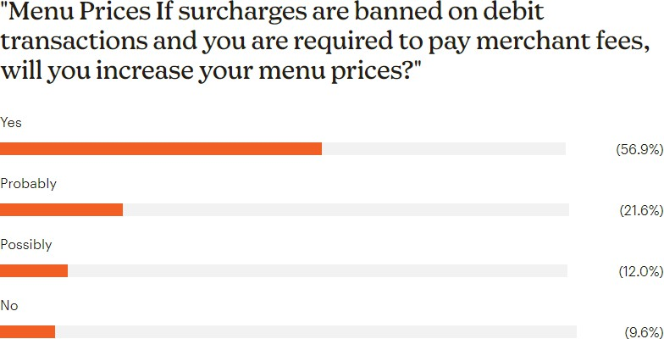

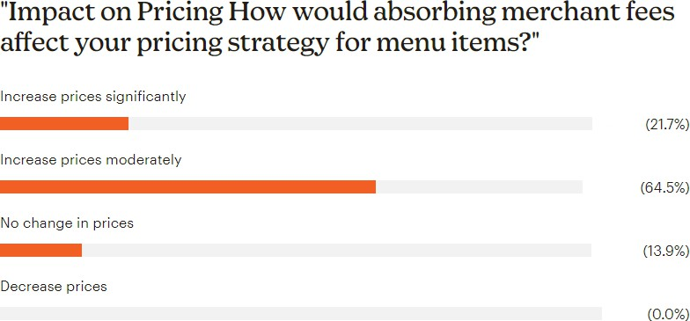

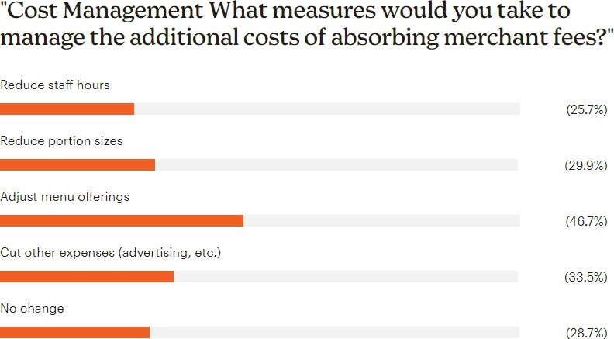

- Reliance on “expectations” rather than enforceable obligations for cost pass-through, scheme fee justification, and acquirer transparency is insufficient. Without binding requirements and penalties for non-compliance, the intended competition benefits may not materialise.
- Incomplete capture of mobile wallet and online transaction costs: Given the rapid consumer shift to contactless and wallet-based payments, the regulatory framework must anticipate and address the higher scheme and interchange fees often associated with these channels.
Variations to improve public benefit
- Maintain the ability to surcharge at least credit card and foreign card transactions until there is demonstrable evidence — through independent monitoring — that interchange savings are being passed through in full to merchants across all sectors.
- Introduce mandatory pass-through provisions with annual ACCC audits to ensure acquirers are not retaining savings.
- Implement a small business-specific transparency requirement, with cost of acceptance data clearly broken down for businesses under $10m turnover and communicated in plain language.
Additional evidence the RBA should consider
- Data on actual pass-through rates from previous interchange cap reductions, disaggregated by merchant size and sector.
- Hospitality-specific transaction mix analysis, to model the real-world impact of removing surcharging when weighted against the sector’s average payment profile (high debit use, small-ticket size, high transaction volume).

We recommend a sequenced implementation:
1. Reduce interchange caps.
2. Turn on transparency, simplification, LCR default on, and enforceable scheme fee guardrails.
3. Only then adjust surcharging settings (if at all).
This order ensures wholesale savings are real and cannot be re inflated by scheme fees, thereby softening the blow to merchants and preserving price transparency.
In short: sequence the package. Lower interchange first; lock in scheme fee transparency, simplification, LCR default on, and enforceable backstops second; then, after a 12-18 month implementation window for contracts and systems, consider any surcharging changes, so savings reach merchants and cannot be undone by fee drift.

Q13 – Feedback on Implementation Timeline
The proposed 1 July 2026 commencement for the major changes is not achievable for most restaurants and cafés and we support a 1 July 2027 implementation if:
- Clear, finalised rules are published by end-2026, with no late-stage amendments.
- Acquirers are required to notify merchants of the exact changes to their rates at least 12 months before implementation.
However, there are two timing concerns:
- Policy 1 (Any Removal of Surcharging-which we do not support) should not take effect until there is an audited, public report confirming that interchange savings are being passed through. Otherwise, businesses could face higher net costs immediately on implementation.
- Transparency measures (Policies 6–11) should commence — ideally in 2026 — so merchants can use the data to renegotiate plans before surcharging is removed.
Noting-ARCA supports a commencement no sooner than 12-18 months after final standards to allow repricing, software changes (POS/PSP), signage, staff training, and contract renegotiation.

Q14 – Draft Standards in Appendix D
While the draft standards appear to align with the stated objectives, there are several areas where they do not fully address the needs of small hospitality businesses:
- Pass-through enforcement: The draft standards set disclosure obligations but do not include a compliance mechanism to ensure that wholesale fee reductions flow through to merchant pricing.
- Sector-specific impacts: The standards do not explicitly account for high-volume, low-value transaction environments like cafés, where even small per-transaction increases materially affect profitability.
- Simplicity and clarity: Disclosures must be in plain language and provided in merchant statements in a way that allows an owner-operator — not just an accountant — to easily identify cost changes and competitive alternatives.
- Inclusion of all payment channels: The standards should ensure that fees and interchange rates for mobile wallet, tokenised, and online transactions are captured with the same transparency as card-present transactions.
Without these additions, there is a risk that the policy objectives will be met only partially, and small merchants in the hospitality sector — despite being the intended beneficiaries — could end up disadvantaged.

Thank you.
Wes Lambert CPA, FGIA, CAE, AAiP, MAICD
Chief Executive Officer
Australian Restaurant & Cafe Association Ltd. M: 0488579888
E: wes@arca.org.au

ABS Counts of Australian Businesses, including Entries and Exits, June 2019 to June 2024, August 2024

